Founders Brewery Tour
4:30 Saturday
$15 per person
Limit 20
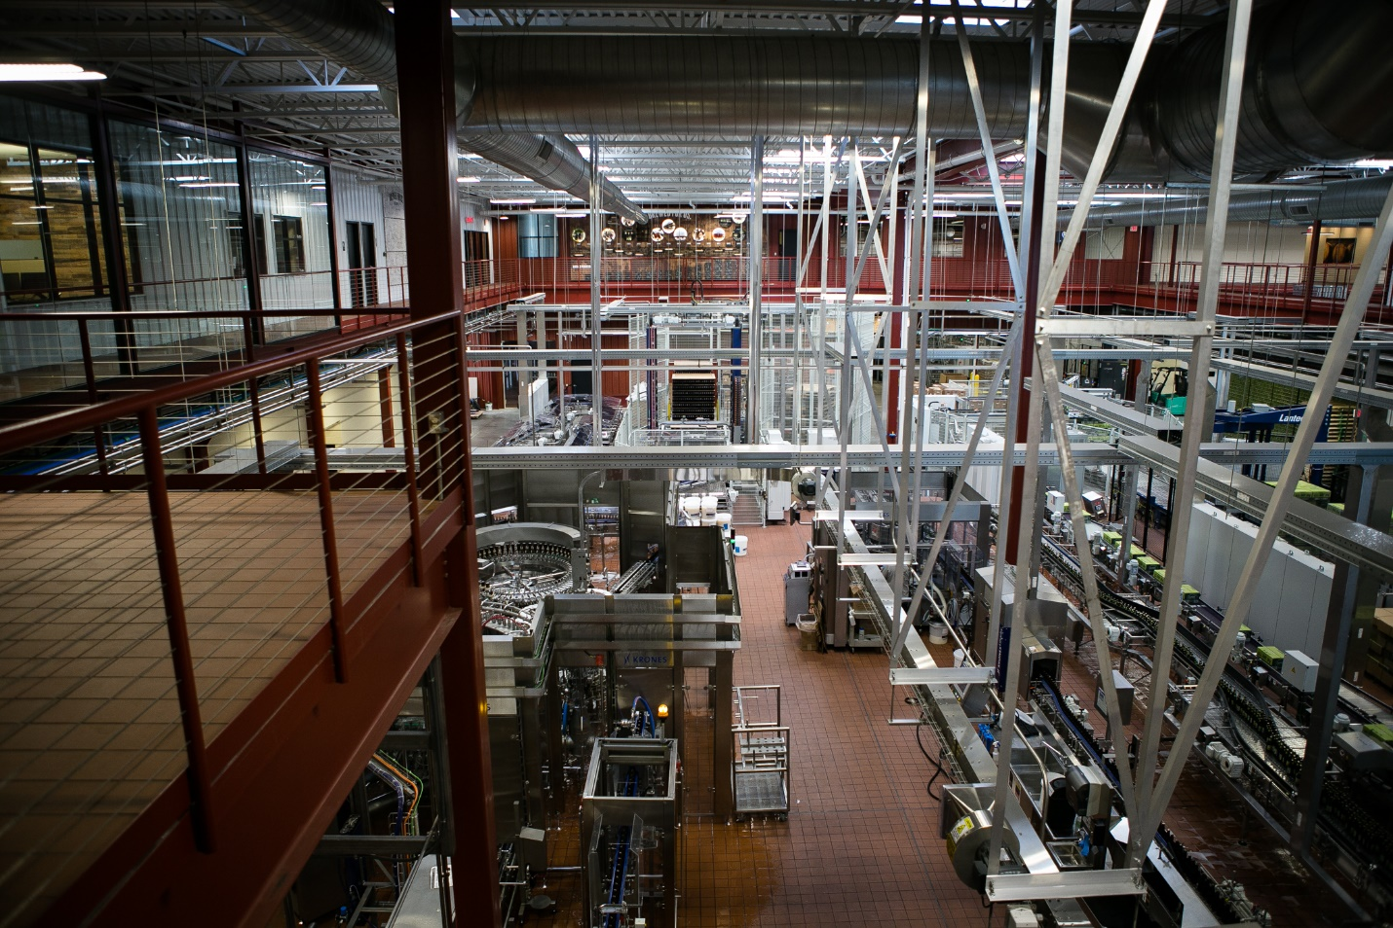
30 minute tour with tastings and swag!
Contact Kathy to get on the list!
616-935-9559

