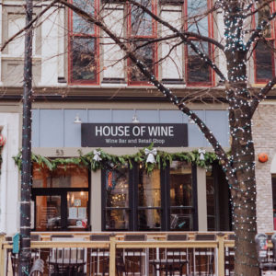
HOUSE OF WINE
Flights of 3.
$9-$17
Limit 10!
Call Kathy to get on the list
616-935-9559

