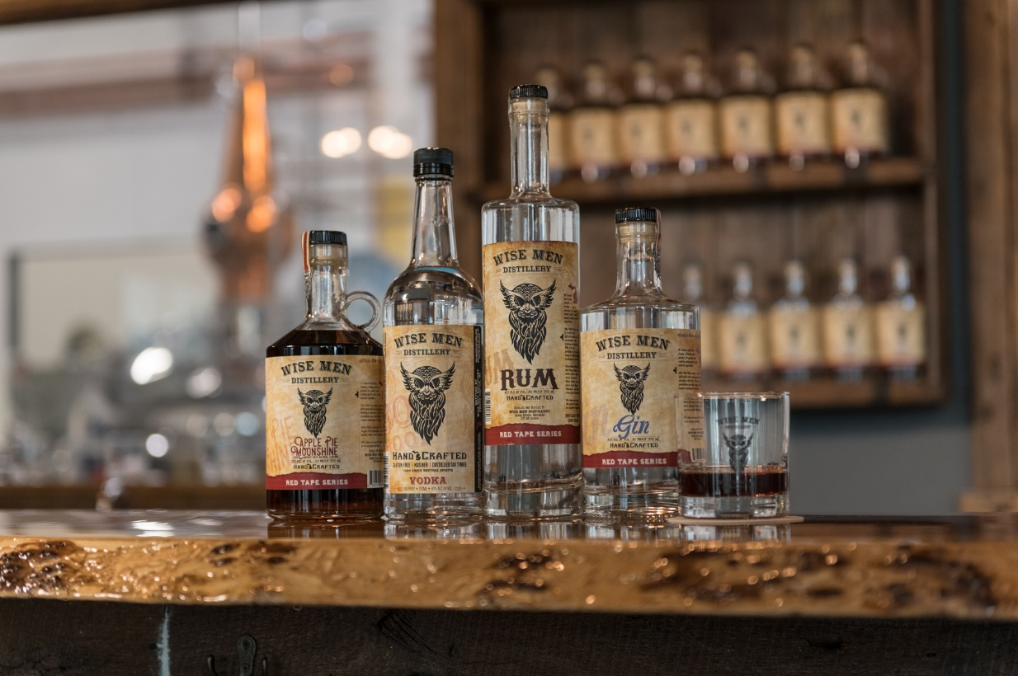
Wise Men Distillery

Wise Men Distillery’s Tasting Rooms offer small batch Vodka, Rum, Gin, White Whiskey, Naturally Flavored Whiskeys, Bourbon, and naturally flavored Vodka Hard Seltzers in a laid-back, down to earth environment.

$10 – 30-minute tour

Tasting 3 flights

Limit 15

Call Kathy to get on the list

616-935-9559

