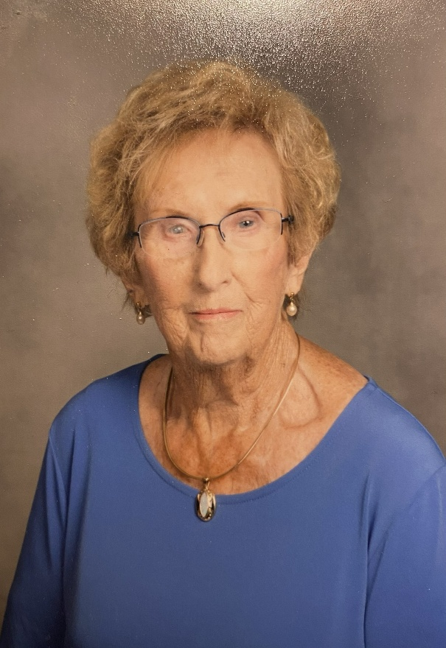

Houghton Lake Rotary Club Celebrates Barbara Ann Souder
Houghton Lake, MI — April 10, 2026 — Family, friends, and fellow Rotarians are proud to celebrate a remarkable milestone as Barbara Ann Souder turns 90 years old on April 10th.
A beloved community leader and dedicated volunteer, Barb has spent nearly five decades making a lasting impact in the Prudenville and Houghton Lake area.
Born on April 10, 1936, in Paducah, Barb (Phipps) Souder is the eldest of three daughters of Dr. Edward Chauncey and Sarah Jane Phipps. Her early years took her across several states including Kentucky, Virginia, Texas, and Ohio before her family settled in Fostoria, where she completed her schooling.
Barb married her high school sweetheart, Lowell Souder, on November 11, 1956. Together, they built a life grounded in family, hard work, and community service. After earning her degree as a Medical Lab Technician from Elkhart University, Barb balanced career, motherhood, and military life while Lowell served in the U.S. Army, including time spent living in Germany.
In 1977, after years of summer visits, Barb and her family made the life-changing decision to move to Prudenville. There, they purchased and operated Gas Lite Manor on the shores of Houghton Lake for 22 years. The resort became a cherished destination, known not only for its scenic beauty but for the welcoming spirit Barb and her family brought to every guest—many of whom returned year after year and became lifelong friends.
Barb’s legacy extends far beyond her business endeavors. She has been a devoted member of the United Methodist Church since 1977, where she continues to serve through the Bell Choir and other ministries. Her commitment to professional and civic organizations is equally impressive, including nearly four decades with the American Business Women’s Association, where she served as President and in multiple leadership roles.
A cornerstone of the Houghton Lake Rotary Club, Barb has been an active Rotarian for 39 years. She served as Club President in 1993–1994, held the role of Secretary for over 13 years, and continues to serve on the Board of Directors. Her leadership and dedication have helped shape countless community projects, scholarships, and service initiatives that continue to benefit our community today.
In addition to her service, Barb has contributed her time and expertise to the Munson Healthcare Grayling Hospital board for 12 years, further demonstrating her commitment to the well-being of her community.
Barb is the proud mother of three children David, Diane, and Mark and a loving grandmother to 11 grandchildren and 3 great-grandchildren. Today, she continues to enjoy the simple pleasures of life: spending time outdoors, walking her dog Gizmo, gathering with friends, and cherishing moments with her family.
“Barb represents the very best of what it means to serve others,” said Houghton Lake Rotary President, Gary Gandolfi. “Her kindness, leadership, and dedication have impacted so many in our community. We are incredibly fortunate to celebrate this milestone with her.”
Happy 90th Birthday, Barb! Your legacy continues to inspire us all.

Media Contact:
Heather Marra
Houghton Lake Rotary Club
In the photo Rotarians Susan Tyer, Diane Nielsen, Friend Paula Fuller, Barb Souder, Rhonda Fossitt, Cole Morison, Jim VanSice, Rhonda Lamberg, Ben Elliott, and Ben Williams

--
Gary D Gandolfi
(989) 329-3690

