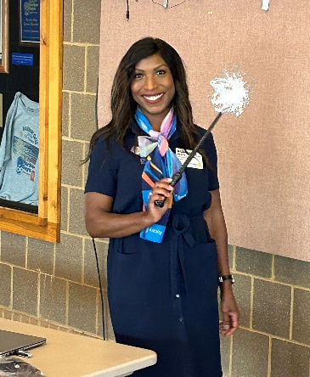
PDG, Brianna Scott, District Membership Chair
I’m thrilled to step into the role of District 6290 Membership Committee Chair, and I’m energized by the momentum already building across our district. Membership is the heartbeat of Rotary—not just the number of people in our clubs, but the quality of the experience we create for every member. This year, we’re leaning into that truth with purpose, creativity, and a renewed commitment to belonging.
Rotary International reminds us that “inclusion is essential to Rotary’s culture. We actively seek to build a diverse, equitable, and inclusive environment where people from all backgrounds can connect, grow, and thrive.” That vision will guide every initiative we take on in District 6290. Our goal is to help clubs become more accessible, more welcoming, and more engaging places where every member feels valued and every prospective member sees a home.
To support this work, District 6290 is launching several membership initiatives designed to meet clubs where they are and help them grow. We’ll explore flexible club models, innovative outreach strategies, and engagement practices that strengthen retention and deepen connection. We want to help clubs create experiences that spark joy, build friendships, and inspire service.
To make this happen, the Membership Committee will serve as a year-round resource. Whether your club is looking to refresh its member experience, strengthen recruitment, or rethink how it fosters belonging, we’re here to collaborate and support you. Expect tools, guidance, and hands-on help tailored to your club’s unique needs.

This year, our committee will organize its work through several focused subcommittees:
- Club Support & Engagement Subcommittee — Helping clubs strengthen retention, member satisfaction, and club culture.
- New Club Development & Innovative Models Subcommittee — Exploring satellite clubs, cause-based clubs, corporate memberships, and other flexible approaches.
- Diversity, Equity, Inclusion & Belonging (DEIB) Subcommittee — Supporting clubs in creating welcoming environments aligned with Rotary’s DEI principles.
- Outreach & Recruitment Subcommittee — Developing strategies, tools, and messaging to help clubs attract new members.

These subcommittees will allow us to focus deeply, act intentionally, and deliver meaningful support throughout the year.

To stay aligned and forward-moving, the full Membership Committee will meet monthly—and we’re growing! Fresh perspectives and new energy make us stronger, and we are actively seeking additional committee members who are passionate about strengthening Rotary’s future.

If you’re interested in joining one of our subcommittees or simply want to learn more, please reach out to me. Together, we can make District 6290 a place where every member feels at home and every club thrives.

