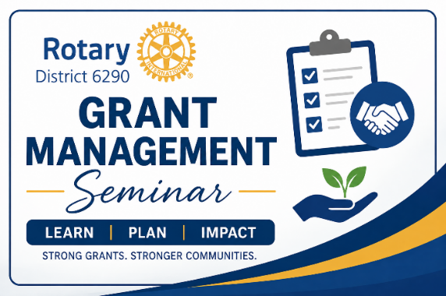
If your club plans to apply for a District or Global Grant, we invite you to join us for a Grant Management Seminar on Monday, August 10, at 7:00 PM via Zoom.
The seminar is expected to last 60–75 minutes and will provide the information your club needs to meet the Grant Management Seminar requirement.
What You Need to Know
- Date: Monday, August 10
- Time: 7:00 PM
- Location: Zoom
- Duration: Approximately 60–75 minutes
Topic: Grant Management Seminar - 2026 Grant Cycle - Hosted by Mark Andresky and Linda Falstad
Time: Aug 10, 2026 07:00 PM Eastern Time (US and Canada)
Join Zoom Meeting
https://us02web.zoom.us/j/89019811279?pwd=PodyTNUnYFIBbUK1R3y3ncuT7H7ykA.1
Meeting ID: 890 1981 1279
Passcode: 782782
The session will be recorded and made available afterward for anyone who is unable to attend the live presentation.
During the seminar, we will display a QR code that links to a mandatory Google Form Quiz. This quiz must be completed and submitted for your club to satisfy the Grant Management Seminar requirement and qualify to submit a grant application.

While the recording will be available, we strongly encourage you to attend the live session. Attending live gives you the opportunity to ask questions, hear questions from other clubs, and participate in the discussion. If there is significant interest, we may also offer additional live Zoom sessions.

We look forward to helping your club prepare for another successful year of Rotary grants!

