Agenda Items for Virtual Meetings with Club Presidents

1st Mtg, two months into presidents’ year
- How’s it going?
  - What community programs/projects you did over the summer? How did they go? Lessons learned?
  - What fundraisers did you do over the summer? How did those go? Lessons learned?
  - Did DG visit? Did he/she attend your board meeting? How did it go?
- Your role as the president
  - How have club & board meetings been going?
  - Does your club meet every week? Are some weeks a social event or service project?
  - What challenges are you experiencing?
  - What discoveries have you made that are helping you in your leadership role?
- Updates from District

2nd Mtg, before Christmas
- How’s it going?
  - Have you held club assemblies? What do you cover at assemblies?
  - Has your club done Visioning? If yes, how is the implementation of action plan going?
  - Any challenges or successes to share
  - Did you do an End Polio Now fundraiser? How did it go? Lessons learned?
  - Tracking your TRF donations at Rotary.org
- Membership satisfaction: Share the infographic and discuss what parts of the club experience do you think your club does well? Share examples or your opinion on what makes that strong for your club? Are there any of these parts that you’d like to see stronger for your club?

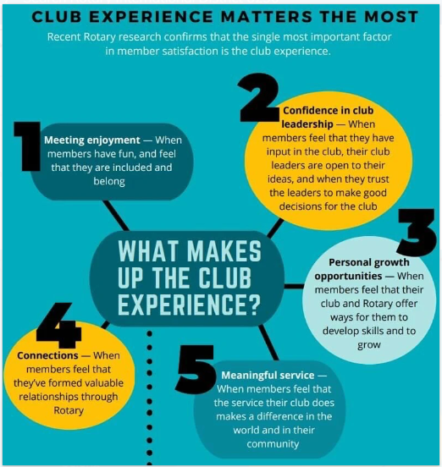
- Updates from District
3rd Mtg, February, invite PEs to attend
- How’s it going
  - Implementation of Visioning action plan or have you set a date for Vision Facilitation
  - How’s attendance/participation in club meetings
  - Success/accomplishments the past couple of months
  - Interesting speakers you’ve had
  - Supports available on the District website, www.ridistrict6290.org
    - Membership engagement webinars, “Being Simply Irresistible”
- Has your leadership team identified a President Nominee Designate?
- Have you done or are you planning a collaborative activity with another Rotary Club?
  - Holiday dinner? Inviting other clubs to your socials
- PE’s, what you learned at your first Pre-PELS
  - Are you registered for PELS?
  - Discuss Action Plan Assessment
- District updates
  - Strongly recommend your PN attends PELS
  - Register early to assure a room at the Radisson

4th Mtg, May, PEs attend also
- Do you have a membership committee? If yes, do they do an annual member satisfaction survey?
  - Where to find the Membership Toolkit on www.ridistrict6290.org
- Visioning accomplishments for the year and next steps
- www.Rotary.org and trainings for President and other leadership positions in club
  - Review your goals & update them
  - PEs, have your goals been shared with your board and approved?
  - Looking up your club standing with TRF
    - Looking up who has given this year
    - Review how to setup Direct Donation
- Any interesting speakers you would recommend
- District updates
  - Dues update will be coming soon

Other ideas to consider:
- Start each meeting with an icebreaker question—attendees will get to know each other better and develop trust
- Statement at the start of each meeting that we’re here to learn and encourage
- Statement at the end of each meeting to keep in contact with you if any questions or concerns come up
  - Kathy Hegedus and the DG get lots of emails, emailing you first may get them a quicker response
- Keep a list going of district updates you hear from AGs & Coordinator mtgs

