Holland After Hours Club Seeking Partners for Tanzania Water Project
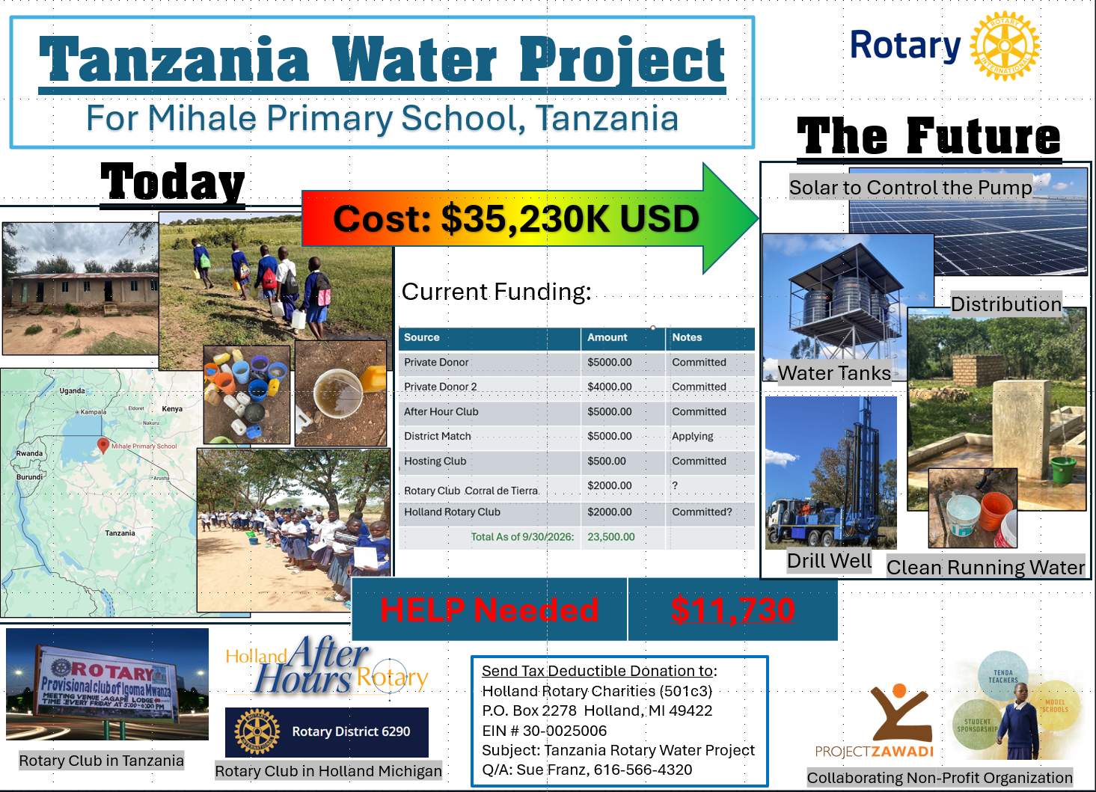
Calling all Rotarians from District 6290 to participate a water project in Tanzania!
In collaboration with Igoma Rotary Club in Tanzania and Project Zawadi, a U.S. nonprofit organization, Holland After Hour club is leading a project in Tanzania to provide clean water for Mihale Primary School. This project will allow us to drill well, install a pump powered by solar panel, and distribute water to the school, as well as the surrounding communities. Currently, there is no water in the school or nearby communities. Students walk miles to get water which is not clean. The new water system will allow the students to have clean water on site. Local communities can also tap into the water system to provide a health living environment for the students. After the completion of the system, it will be maintained and sustained with the collaboration of local Igoma Rotary Club in Tanzania and a US nonprofit organization, Project Zawadi (www. projectzawadi.org), that has had a presence in Tanzania for more than 25 years, Its mission is to ensure Tanzanian children and youth to have access to a quality education.
We would love to have more Rotarians and Rotary clubs join us on this project. The deadline for a district matching grant application is October 15. Please let us know if you would like to be a partner to make this project a success. If you have questions, please contact Sue Franz at sue.franz.4320@gmail.com.

