Holland Rotary Seeking Project Partners to Outfit Hospitals in Kenya
The Holland Rotary Noon Club and Holland After Hours Club are seeking partners for a Rotary Global Grant to equip three medical facilities in Kenya with critical, lifesaving equipment.
Population growth and aging or absent equipment severely strains local healthcare capacity. Urban hospitals face extreme overcrowding—often forcing four to five patients to share a single bed—while rural facilities lack the resources to acquire, maintain, or replace medical tools across geographically spread communities.

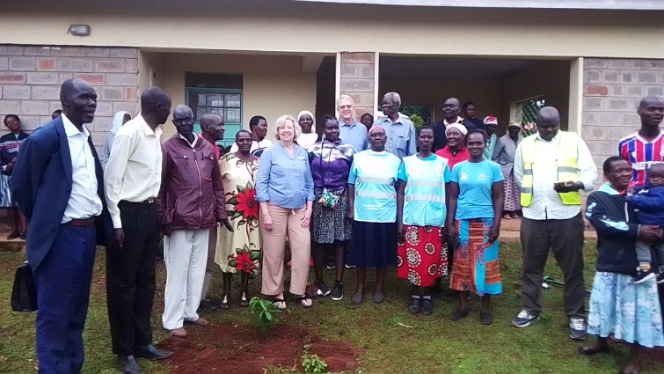

Site #1: Serving 150,000 people, this facility has two newly constructed operating rooms with no surgical equipment. The administrator noted that equipping these rooms could have saved every patient who recently died there.

Site #2: An unfinished clinic serving a community of 3,000 currently relies on a single aging midwife. Completing its construction—adding a well, solar power, laboratory equipment, and furnishings—will enable accreditation and allow government-funded clinical officers to provide essential maternal, immunization, and diagnostic care.

Site #3: A functional rural hospital currently performs surgeries using hardware-store lights due to equipment failure. An ongoing 22-bed expansion and second surgical theatre will separate maternal care from the general population, reducing disease transmission and expanding local surgical access.

We are prioritizing Site #3 with plans to assist the other locations as funding allows. While Kenya's improved insurance reimbursement model supports operational costs, funding full equipment installations remains beyond these communities' reach. Matching funds are available through District 6290 and Rotary International.

Help Us Bring Lifesaving Healthcare to Kenya
We are seeking Rotary clubs and members to partner with us to provide critical healthcare equipment to Kenyan hospitals and clinics. From operating rooms without surgical equipment to rural hospitals performing surgery with hardware-store lights, these communities face urgent healthcare needs. With the right equipment, local medical teams can save lives, expand access to care, and serve thousands of people more effectively.

To get involved or request more information, contact Kathy DeVries at kathyldevries@gmail.com or check out the needs at https://app.givegrove.com/medicalequipmentfundraiser/fund-a-need.

