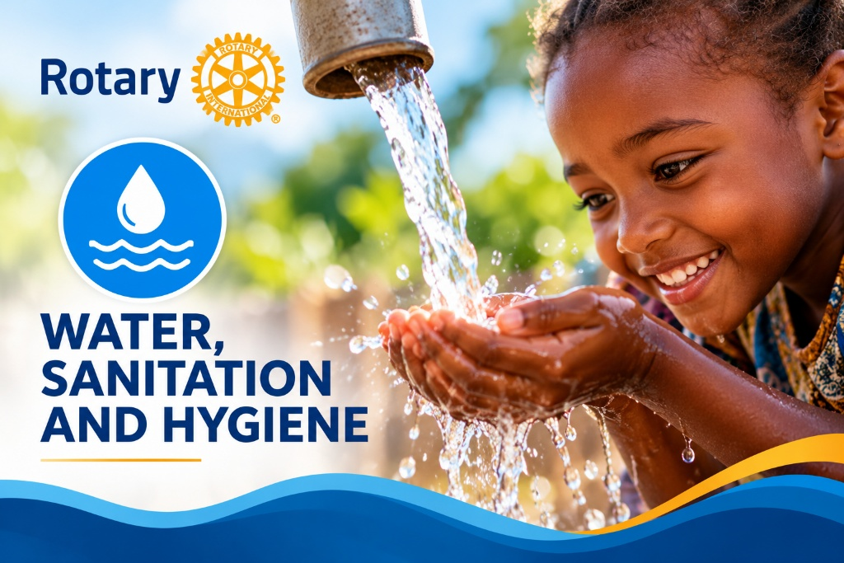

The Rotary Club of Grand Haven is soliciting Clubs interested in participating in a Global Grant "Water, Sanitation and Hygiene" in the Village of Mantasonas and Los Cedros, in Honduras. This grant when approved by Rotary International will repair a broken and ageing water system. The funds in this grant will purchase piping, approximately 2.5 miles of piping from the water source to the village. It will repair the existing water storage Tank , including all necessary pressure reducing valves. The Village of Mantassonas consists of 142 Homes , or 240 Families. The Water will be piped to the school and a multi-level sink will be constructed as well as the need for a shoer facility for girls.
The village of Los Cedros requires a major repair, install new piping from the water source to the village holding tank. Approximately 1.5 Miles and construct a water holding tank for 1,500 gallons. The village consists of 60 houses; it has a school and church.
The sanitary portions of this grant will be based on the needs assessment and may address the construction of Latrines or the removal of trash, plastic, paper, and metal in order to protect the environment and ground water.
The Higuito Organization together with the villages conducted an in-depth needs assessment. The final document of both assessments will be uploaded into the global grant file. The Higuito organization will be an important partner in this global grant. The name Higuito is based on the Higuito River that runs thru the area where most of the villages are located. It was founded by 17 villages in order to help each other, provide technical and financial support were needed.
Contact Gernot Runschke for more information: gernotrunschke@gmail.com

