A Rotary Global Grant Opportunity Supporting the Thandisi Skills Centre
Roscommon Rotary is inviting District 6290 Rotary Clubs to join us in a meaningful international service project through a Rotary Global Grant supporting the Thandisi Skills Centre in KwaZulu-Natal, South Africa.
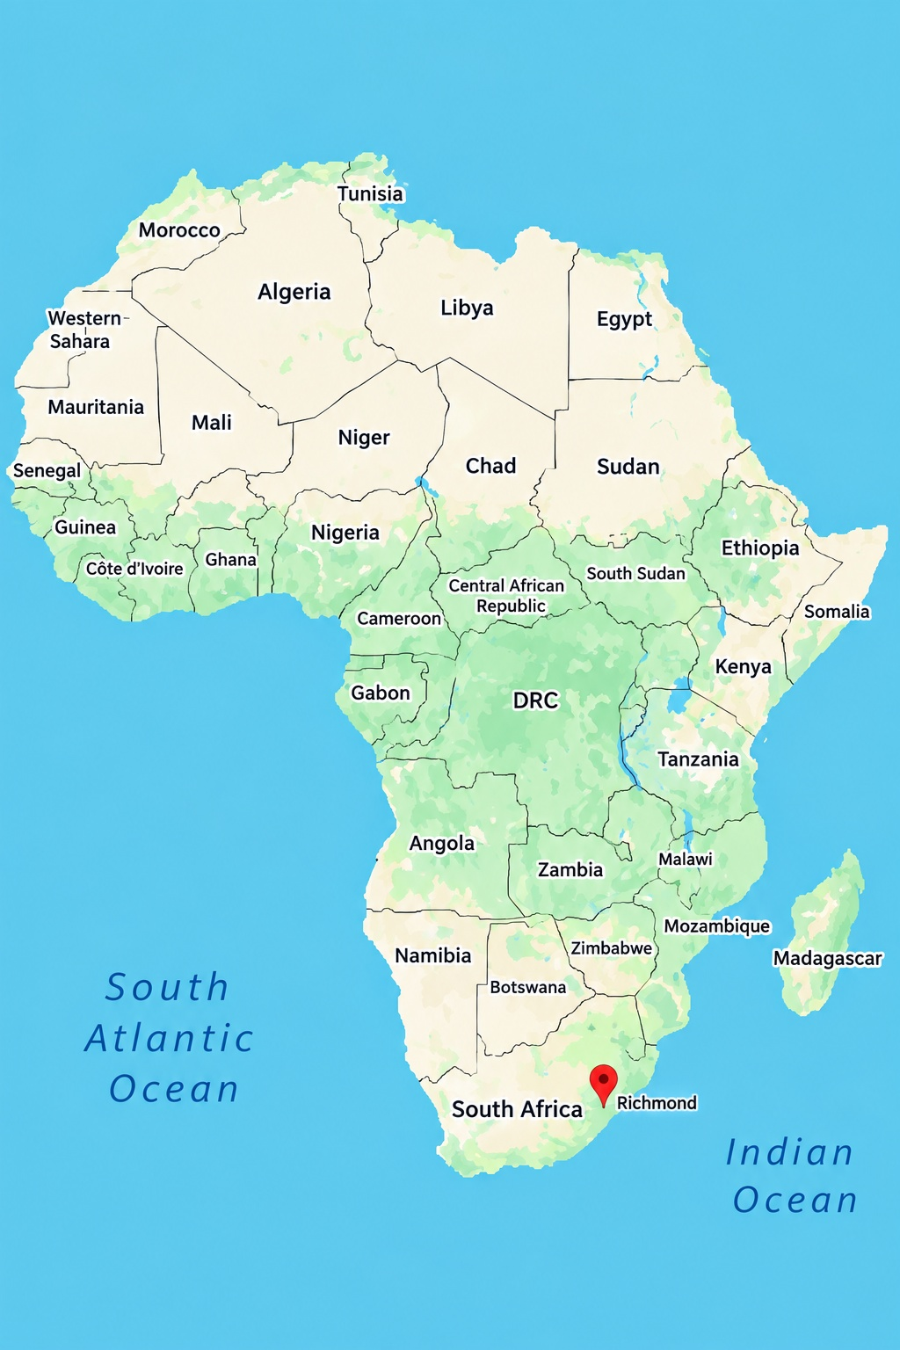
The Thandisi Skills Centre (TSC) is a community-driven educational initiative serving young adults, primarily ages 18–35, in a large impoverished area in the Municipality of Richmond. The Centre was established to provide practical, marketable skills that can help young people secure employment, support their families, and create their own small businesses.
A Community Needs Assessment identified four critical areas of training:
- Healthcare – Home-Based Medical Care
- Information & Computer Technology (ICT)
- Sustainable Farming – Poultry Management and Livestock Care
- Food Security – Canning and Preserving
The Global Grant will provide the specialized equipment necessary to establish and strengthen these training programs. With the proper resources, TSC graduates will be better prepared to enter the local workforce or establish micro-enterprises of their own.
But the impact goes far beyond the graduates. Their new skills will benefit their families, create a larger pool of qualified workers for local employers, provide home-based healthcare to families in need, and strengthen food production and preservation throughout the community.
We invite your Rotary Club to partner with Roscommon Rotary in this Global Grant. By joining together, Rotary Clubs can leverage their resources to create a sustainable, long-term impact in a community where opportunities for education, employment, healthcare, and food security are urgently needed.
For additional information, contact Roscommon Rotarian, Jackie Bertsch at:
jbertsch@charter.net

