ROTARY CLUB BASKETS FOR RAFFLE
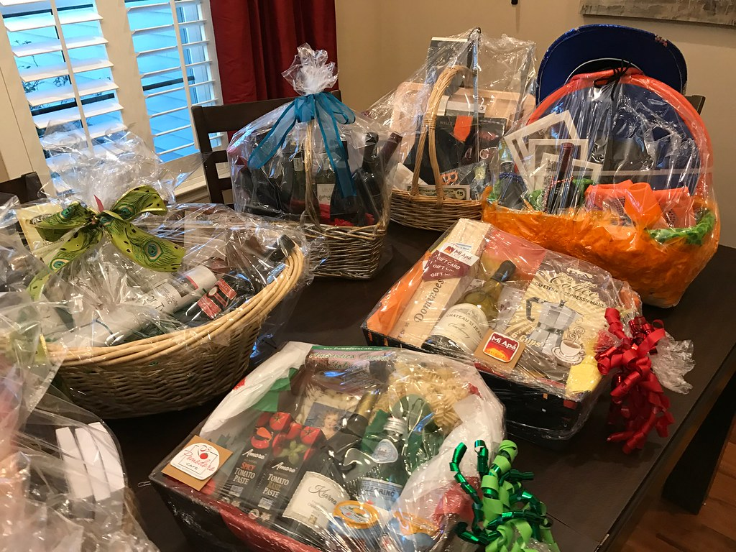

1 TICKET $5.00

5 TICKETS $10.00

20 TICKETS $20.00

