Wine Pull
1 bottle card $10
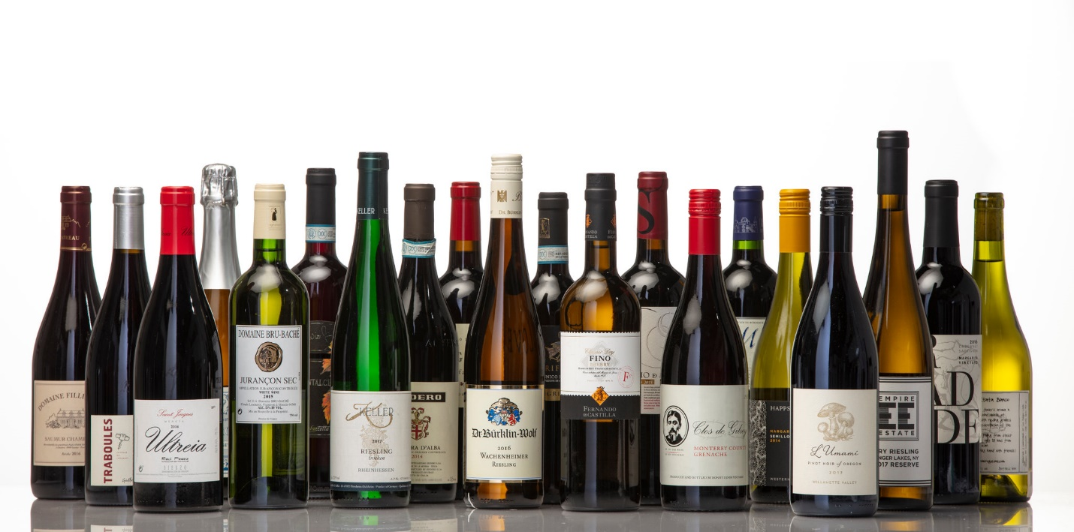
Purchase as many as you want! The more the merrier!!!

