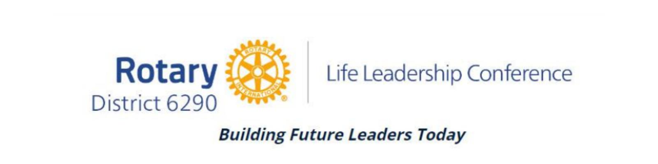
THIS REGISTRATION FORM IS ONLY FOR THOSE STUDENTS WHO HAVE BEEN THROUGH A FULL SCREENING PROCESS OF SELECTION BY A LOCAL ROTARY CLUB IN YOUR AREA OF ROTARY DISTRICT 6290 TO ATTEND THE 2026 ROTARY LIFE LEADERSHIP CONFERENCE, June 17-20, 2026, at Ferris State University.

Please read this document carefully and follow the instructions outlined below. Your registration is not complete until John Noling has a digital or physical copy of your consent form.

Before you begin, please make sure that you have the following:
- your physician's name and phone number, and insurance card at hand
- name and contact information for your local Rotary contact person
- a printer to print the Consent Form that is linked at the end of this form
- a parent/legal guardian available to assist, and to read and sign (in handwriting) the Consent Form that will be printed and emailed or mailed to John Noling

- Complete and submit the Registration Form.
- If you did not complete the Consent Form that is linked in the Registration Form, please follow these instructions:

- Download this document (also linked above) to print and sign in handwriting for both student and parent/guardian.
- This must be completed by May 20, 2026. This is the final step in your registration.

- Follow these directions:
- This document must be printed and signed in handwriting by the student registrant and a parent/legal guardian, and then scanned or photographed and emailed or texted to johnnoling65@gmail.com; 231-670-3740.
- If you would prefer, you can mail it to: John Noling, 2332 View Lane, Muskegon, MI 49445.
- If you do not have access to a printer at this point, please take a screenshot of the Consent Form, locate a printer through a teacher, your school counselor, Rotary contact, or other, and print the screenshot for signing and submitting as noted above.
- If you have questions, call John Noling (LLC co-chair) 231-670-3740.
- Your registration is not complete until John Noling has a digital or physical copy of your consent form.

