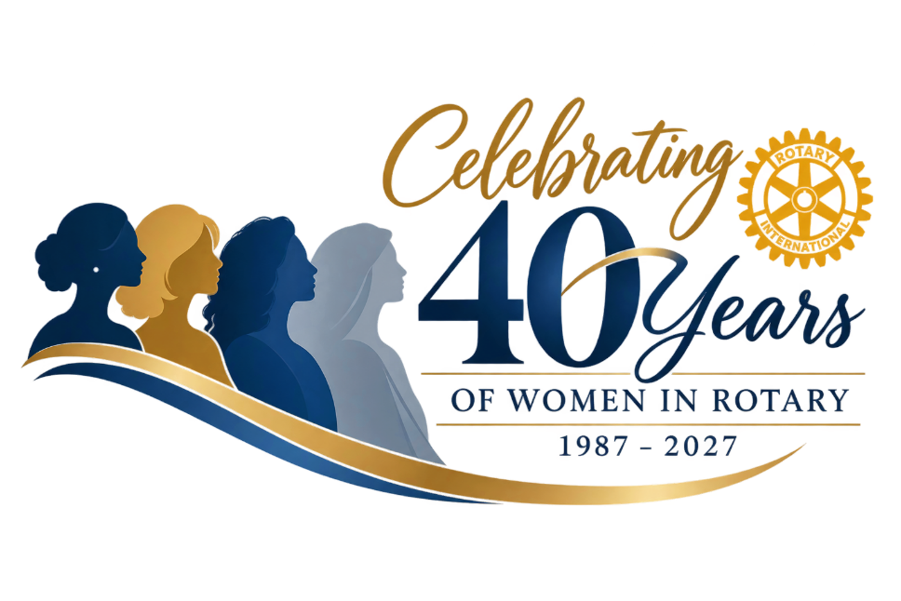

Celebrating 40 Years of Women in Rotary: 1987-2027

Did you know that in 2027, Rotary will mark 40 years since women were admitted to Rotary? In 1987, the U.S. Supreme Court ruled that Rotary clubs may not exclude women from membership on the basis of gender. Rotary International then issued a policy statement that any Rotary club in the United States could admit qualified women into membership. The Rotary Club of Marin Sunrise, California was chartered on May 28, 1987 and became the first club after the U.S. Supreme Court ruling to have women as charter members.

Women Trailblazers in District 6290
To commemorate 40 years of women in Rotary, we would like to ask each club to identify:

- The first women to join the club;
- The first woman to become club president;
- The first woman to become Assistant Governor.

At the district level, we will identify:
- The first woman to become District Governor;
- The first woman to serve on the Rotary International Board.

To be included in D6290’s Celebration of 40 Years of Women in Rotary, please research your club’s history and let us know who your club’s early women pioneers were. Complete the form found on the website by December 15th.

2027 District Conference
During the 2027 District Conference, we plan to have a panel of women who were trailblazers in D6290 (first female Rotarians, club presidents, district governors, and RI board members). Please submit the names of women who joined Rotary in the late 1980s or early 1990s, and those who were early trailblazers serving in leadership positions.

