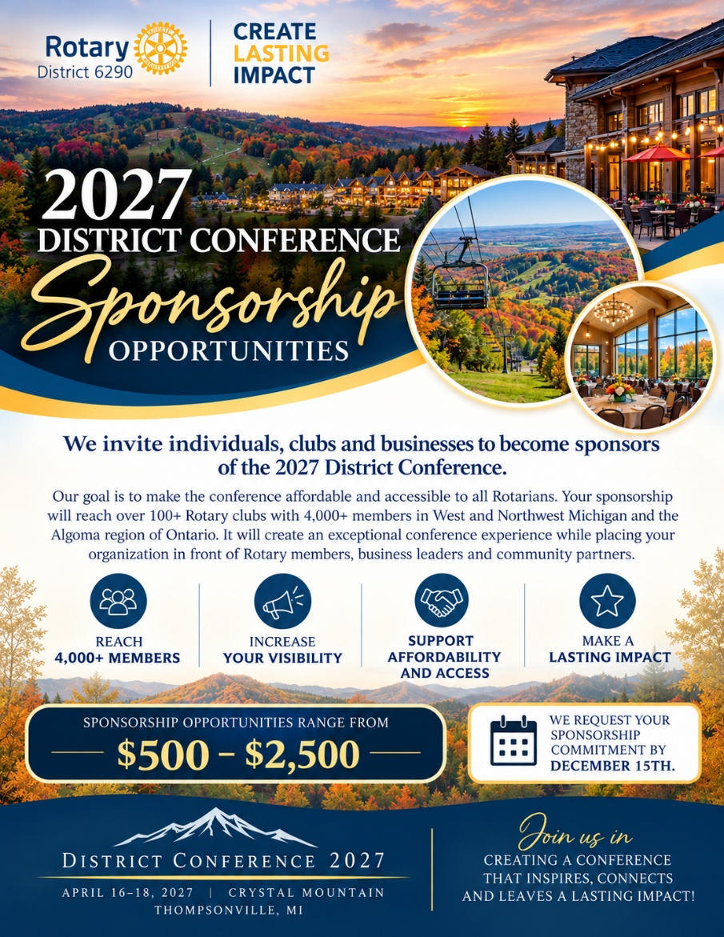
2027 District Conference Sponsorship Opportunities

We invite individuals, clubs and businesses to become sponsors of the 2027 District Conference. Our goal is to make the conference affordable and accessible to all Rotarians. Your sponsorship will reach over 100+ Rotary clubs with 4,000+ members in West and Northwest Michigan and the Algoma region of Ontario. It will create an exceptional conference experience while placing your organization in front of Rotary members, business leaders and community partners. Sponsorship opportunities range from $500-$2,500. We request your sponsorship commitment by December 15th. See flyer for additional details.

