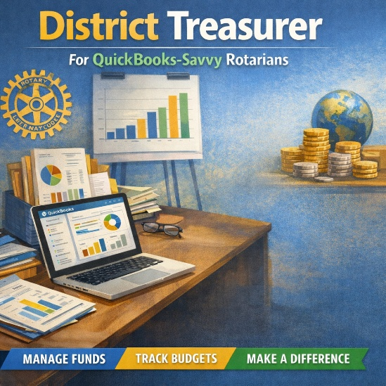

District Treasurer (Perfect for QuickBooks-Savvy Rotarians)
Do you enjoy keeping things organized, making numbers make sense, and ensuring the trains run on time—but don’t necessarily think of yourself as an “accountant”? The District Treasurer role might be a great fit for you.
The District Treasurer is the trusted financial steward for the District Governor, overseeing the district’s operating budget and accounts, including the general fund, district conference, and special project accounts. You’ll use practical, real-world financial skills—especially QuickBooks—to track income and expenses, manage bank transactions and reconciliations, and ensure payments are made accurately and on time.
This role is about clarity and partnership, not complexity. You’ll work closely with the District Governor, Finance Chair, and District Chairs to support budgets, answer questions, and help clubs understand how district funds are used to support Rotary’s mission. You’ll prepare clear financial reports and summaries that help district leaders make informed decisions—no jargon required.
You don’t need to be a CPA. If you’re comfortable with QuickBooks, understand basic bookkeeping practices, and enjoy being reliable and detail-oriented, you already have the core skills needed. You’ll also help train and mentor an apprentice, ensuring strong financial stewardship for the future.
This role is ideal for someone who:
- Is comfortable using QuickBooks and managing real-world finances
- Understands income, expenses, and bank reconciliations
- Enjoys organizing information and keeping records accurate
- Can explain financial information in plain language
- Is dependable, punctual, and detail-oriented
- Has experience in Rotary beyond the club level—or is ready to serve there
If you like being the person others trust to “keep things running smoothly,” the District Treasurer role is a meaningful way to put your skills to work for Rotary—without needing an accounting title.

