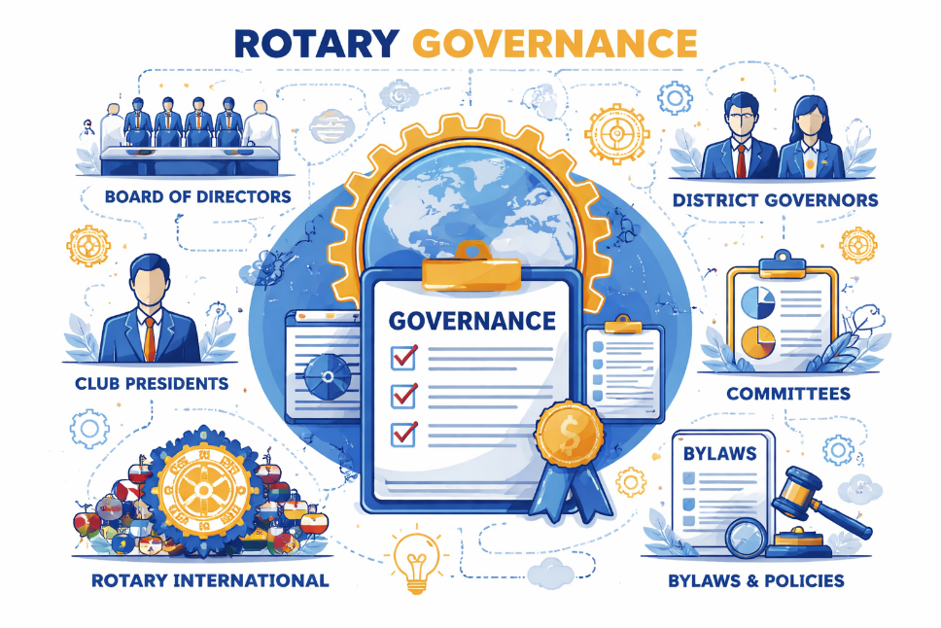

District Parliamentarian (Ex-Officio)
Category: Governance / Advisory
Status: Open
Key Responsibilities
- Advise the DG, Board, and committees on Rotary policies and district bylaws.
- Provide guidance on meeting procedures, voting, and governance issues.
- Review proposed changes to policies and ensure they align with RI guidelines.
Ideal Skills & Experience
- Familiarity with parliamentary procedure and Rotary governance.
- Detail-oriented, fair-minded, and comfortable interpreting policy language.
- Prior board or bylaws committee experience preferred.
Approximate Time Commitment
- 1 hour per month, with peaks around key decision periods.

