ROTARY - WHEELS IN MOTION! August 20, 2025
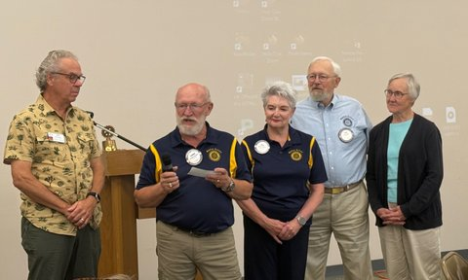
Pictured above, Kip Nickel, TBSC, Gordon Kimbel Manton Rotary President, Linda Kimbel Manton Rotary Sec/Treas, Paul and Jane Sawin Manton Rotary members.
From new bicycles wheels to old logging wheels, the Rotary Club of Manton is always working to either raise money for great projects or helping other non-profits.
The Rotary Club of Manton is currently excited about their continuing partnership with the Traverse Bay Sunrise Club for the third year in a row for an international project, the Secondary School Bicycle share project in the Mangochi District of Malawi, Africa. The Manton Club has contributed a total of $5000 towards this program.
President Kimbel said the financial commitment from a small club like Manton (16 members) shows our strong obligation to the international focus of Rotary. In addition, the Manton Club fundraising supports many other local programs, i.e. the Manton Senior Center, The Manton Jr & Sr High School Robotics Team, the annual Manton Family Fun Festival, the MHS Outdoor Education programs, MHS Girls Volleyball, Cross Country and the Outdoor Adventure Club.
Rotary President Gordon Kimbel jokes that there’s never a dull moment when your involved with Rotary! In September, it’s the annual Manton Labor Day Festival Chicken BBQ, which is our major fundraiser. We also clean our 3-mile stretch of M42 East for Adopt-A-Highway in September, April and July. November and December will find us ringing the bell for the Salvation Army and working our Stuffed Animal booth at Project Christmas. Winter slows down a bit, but we are busy planning our activities like cleaning and painting at Manton Rotary Park, and reading to the Manton Kindergarten classes for Reading Awareness month. Throughout the year we volunteer once a month at the Methodist Church Community Dinner.
The Club’s current challenge is to raise funds for a roof to cover the “Big Red Wheels” a century old logging vehicle that resides in Manton’s Rotary Park. 