What is Vision Facilitation?

Vision Facilitation is a process in which trained District-level Facilitation Teams support local Rotary Clubs as they envision their future and develop plans to put those goals into action. It is an engaging process which involves club leaders and members in visioning and developing 3-year goals. Club Vision Facilitation takes place over a 4-hour session, typically 5:00–9:00PM or on a Saturday. During the session, a team of District facilitators lead a process consisting of an overview presentation, writing exercise, data collection, consensus voting, and Action Plan development exercise. You can learn more about Vision Facilitation at www.rivisionfacilitation.org.

Impact of Vision Facilitation
Research by the International Vision Facilitation Council indicate that Rotary Clubs that have participated in Vision Facilitation are:
- 4 times more likely to have increased their membership;
- 5-10 times more likely to have been recognized by their District for achieving District goals; and
- 2-3 times more likely to have increased their giving to The Rotary Foundation.

Schedule Vision Facilitation for Your Club
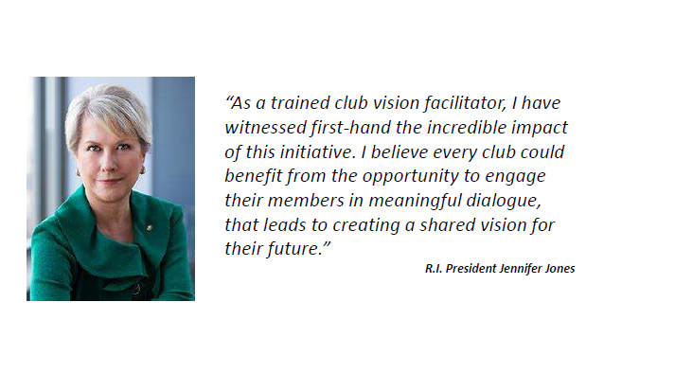
If you have questions or are interested in scheduling a Vision Facilitation session for your club, contact D6290’s Vision Facilitation Chair, Julie Schumaker, at schumakerjulie@gmail.com. She will connect you with the team of trained facilitators in your region.

