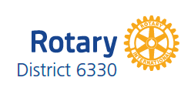
District 6330 Public Image Grant Application Form 2016-17

(Type or write clearly in ink. Answer all items.)

SINGLE CLUB APPLICATION MULTI-CLUB (≥3) APPLICATION
Club name: ________________________ Clubs involved: ______________________
___________________________________
Public Image Grant coordinator: ____________________________________________
E-mail: ___________________________ Phone: _____________________________
Amount of grant being requested for this initiative: $_____________
Contact person (if different from above): __________________________________
E-mail: ___________________________ Phone: _____________________________

1. What is the goal of the proposed initiative in terms of desired result?

2. What is the target audience, and why did you choose that audience?

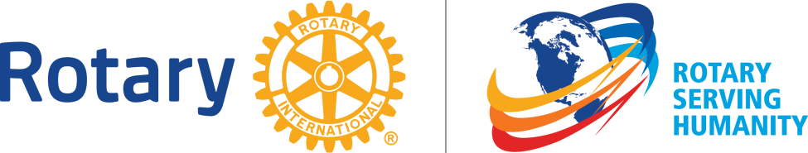

3. What is the planned message content, and how does it relate to the desired result?

4. What medium(ia) is/are to be used, and why?

5. Will this be a one time or repetitive (regularly occurring, or continuous) initiative? If repetitive, will the project materials be re-usable?

6. What is the overall cost of the initiative? NB Cost of Initiative (Club) must be at least 50% of the Overall Cost of Initiative.

Cost of Initiative (Club) __________ Public Image Grant __________

Overall Cost of Initiative __________

IS MY APPLICATION COMPLETE? Note: Please include the Club name on all pages. Use more than one email if attachments will exceed 5 MB.
◻ All questions answered?
◻ Detailed description or visual example of initiative materials provided?
◻ Contact Information provided and correct?
Club name: __________________________________________________
Clubs involved: _________________________________________________________
E-Mail: ________________________________________________________________
Phone (day): ________________________ (evening): __________________________

Submit to: Lawrie Lachapelle lrlachapelle@cogeco.ca
519-869-6699

DEADLINE SEPTEMBER 16th, 2016 @ 18:00

