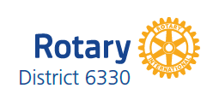

District 6330 Public Image Grants (2016-17)

As you are likely aware, “Enhance Public Image and Awareness” is one of Rotary International’s three strategic priorities. The significance of this strategic priority is underscored by the inclusion of a mandatory Public Image initiative for a Club to achieve a Presidential Citation.

Given the importance that Rotary has placed on enhancing its public image and awareness, District 6330 has again allocated up to $5,000 to be used for grants to clubs for this purpose.

Grant Proposals

Clubs are asked to submit a proposal to the Public Image/Public Awareness Chair for a planned Public Awareness project, requesting matching funds from the District.

The Public Image/Public Awareness Chair will review and accept proposals, and advise submitting clubs. Proposals will be considered on a “first come; first served” basis.

Clubs will be reimbursed from District funds upon receipt of a paid invoice by the Public Image/Public Awareness Chair. Matching funds would be on a one-to-one basis, up to a maximum of $400.00 per individual club, or $1,000.00 per multi-club (≥3) project.

The goal will be to support quality Rotary public image/public awareness initiatives in District 6330.

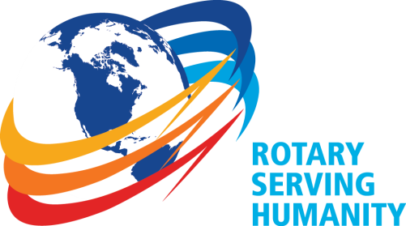
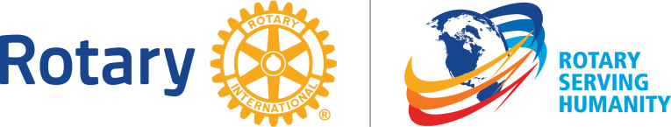

DETAILS District funds have been approved for Public Image grants to help improve public awareness and understanding of what Rotary does, particularly within their local communities. Increasing a community’s awareness of Rotary attracts the interest of potential members, and inspires current Rotarians.
Clubs are to focus on up-to-date branding and relevant messaging using: signage, visual displays, broadcast media, or social media/web-based applications. Projects for the development of graphic designs, and the creation of Club websites, Club Social Media pages and/or Club newsletters will be eligible and are encouraged.
Each club may apply for a Public Image grant of up to $400.00 (individual club) or $1,000.00 (multi-club[≥3]). Only one project per club will be funded.

Public Image grant applications will be assessed on the following criteria:

- Submissions will describe initiatives that will promote Rotary awareness in the community (enhanced visibility, promotional campaign, service projects, events, etc.) The goal of the initiative, the target audience, the message and the medium(ia) to be used must be clearly specified.
- Submission is on time, complete, and legible. Deadline is Friday, September 16th, 2016 at 18:00.
- A detailed description, or visual example, of the proposed materials must be included that demonstrate conformity with Rotary’s visual identity standards
- Initiative to be one time or repetitive use
- Inclusion of contact information (website, facebook, phone)

PROJECTS MUST ADHERE TO ROTARY’S VISUAL IDENTITY STANDARDS in order to be considered.

Please note that grant funds may not be applied to construction, clock towers, cameras or video equipment, clothing, creation of public relations materials that Rotary International already produces, promotional items (including buttons), or fees paid to place the Rotary name or logo on license plates.

Notifications

Public Image grant applicants will be notified of their application’s acceptance (and associated funding), or non-acceptance, by e-mail no later than Friday, September 23rd, 2016.

Payment Procedures

Public Image grant funds are issued as expense reimbursements only. If a Public Image grant application is accepted, the District will be responsible for paying the club only after a paid invoice has been received by the Public Image/Public Awareness Chair.

Contact

District Public Image/Public Awareness Chair

Lawrie Lachapelle
lrlachapelle@cogeco.ca
519-869-6699

IDEAS

Banners

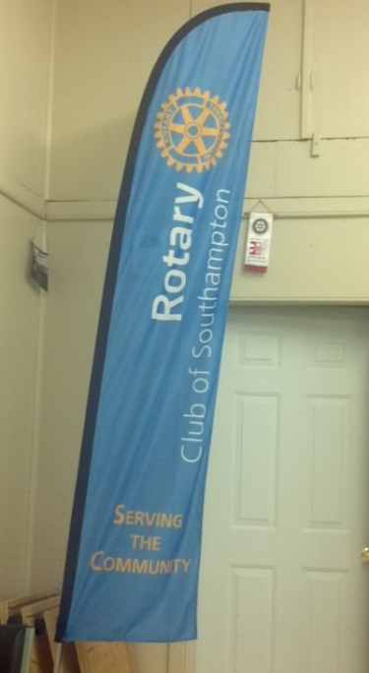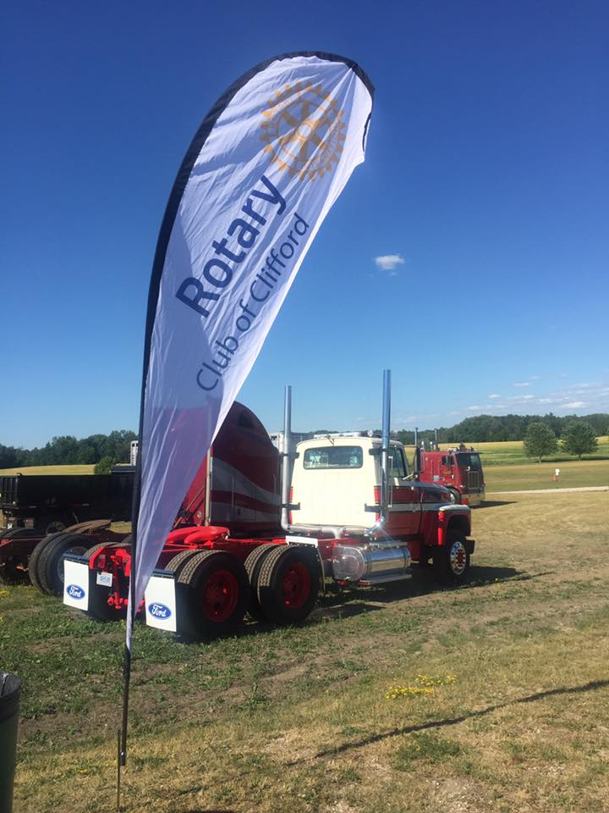

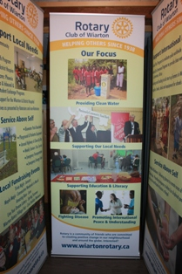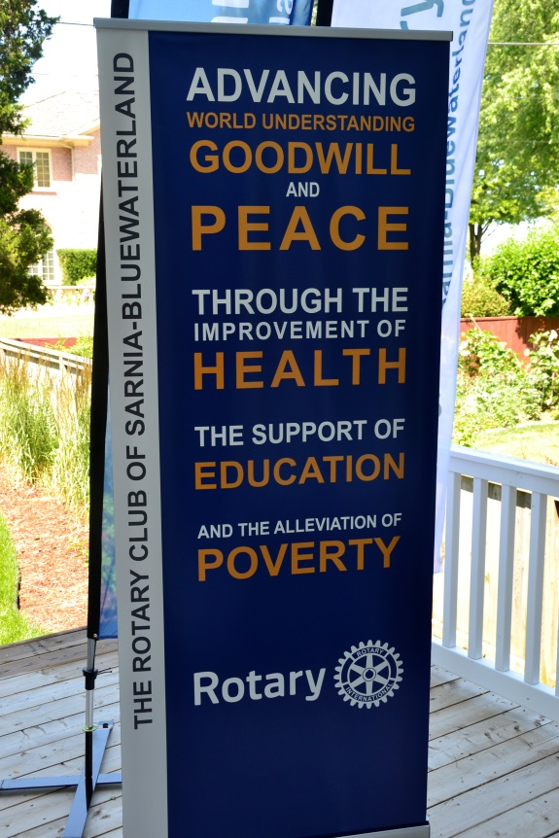

Social Media

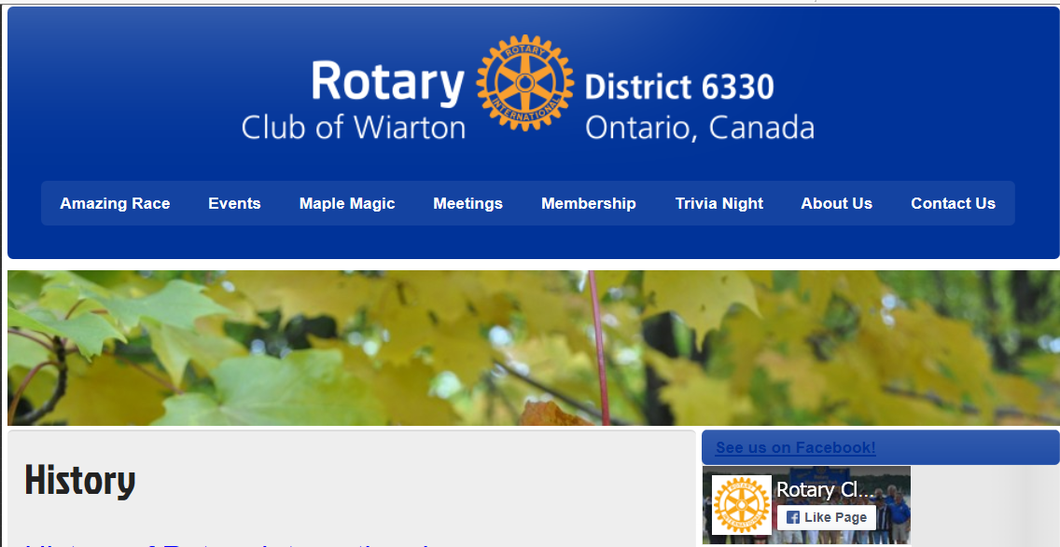

Community Service Club Sign

Multi-message Campaign

