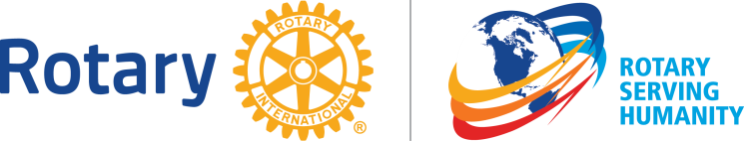

District 6330 Public Image Grant Program 2016-17

“Enhance Public Image and Awareness” remains one of Rotary’s three strategic priorities. Why? The following illustration says it all.

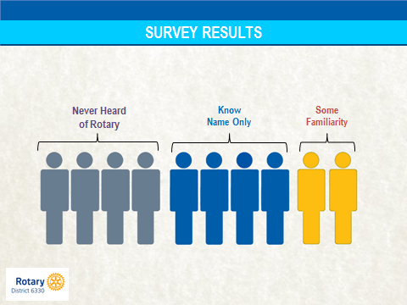

Hence, District 6330 will be offering a Public Image grant program again in 2016-17 to promote awareness of Rotary in your local community; and to promote 100 years of doing good in the world through our Foundation – The Rotary Foundation.

The program will be similar to last year’s, but with several key differences.
- Promoting Rotary’s new brand will be paramount.
- The maximum grant will be $400 to allow as many clubs as possible to participate.
- It will commence this month to allow clubs to make maximum use of their new public image and awareness tools this year.

Details will be provided very soon through your Assistant Governor, and on the District website.

