Books Are Obsolete? “No", Suggests the Book Sale of Sarnia Bluewaterland

Relying on Interactors, students and local volunteers, Sarnia Bluewaterland Rotarians earned $17,200 on a weekend in January. As part of Family Literacy Day their Used Book Sale offered 27,000 books to the local community. People enthusiastically purchased most books for one or two dollars and a grocery bag-full for five dollars on Sunday. The sale has become an event anticipated by the 1,600 people who attended in order to search for their favourite authors. Buyers remarked that they left with, “enough reading for another year".

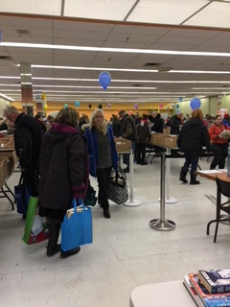

Leftover books were sent to the Rotary Club of Grand Bend for transport to South Africa this spring, and to the Saint Vincent DePaul organization for their store in downtown Sarnia. South Africans will receive 168 full banana boxes of books for their schools and community centres. Rotarians go a long way to keep books from entering a dumpster.

Volunteers are an integral part of the team enabling the Used Book Sale to occur. Twelve volunteers from the community and Bluewater Rotarians categorize and store books every week in preparation for the sale in 2019. Usually held the second weekend in January, the event will soon enter its thirteenth year.

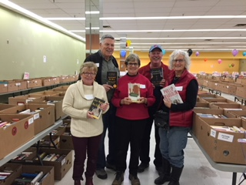

Submitted by:
Camilla McGill
519-332-9288
wsynergy.mcgill@gmail.com

