Does this picture suggest, a literacy project?  Consider financial literacy.  What can middle-school children learn from a jar of Christmas-sweet treats?

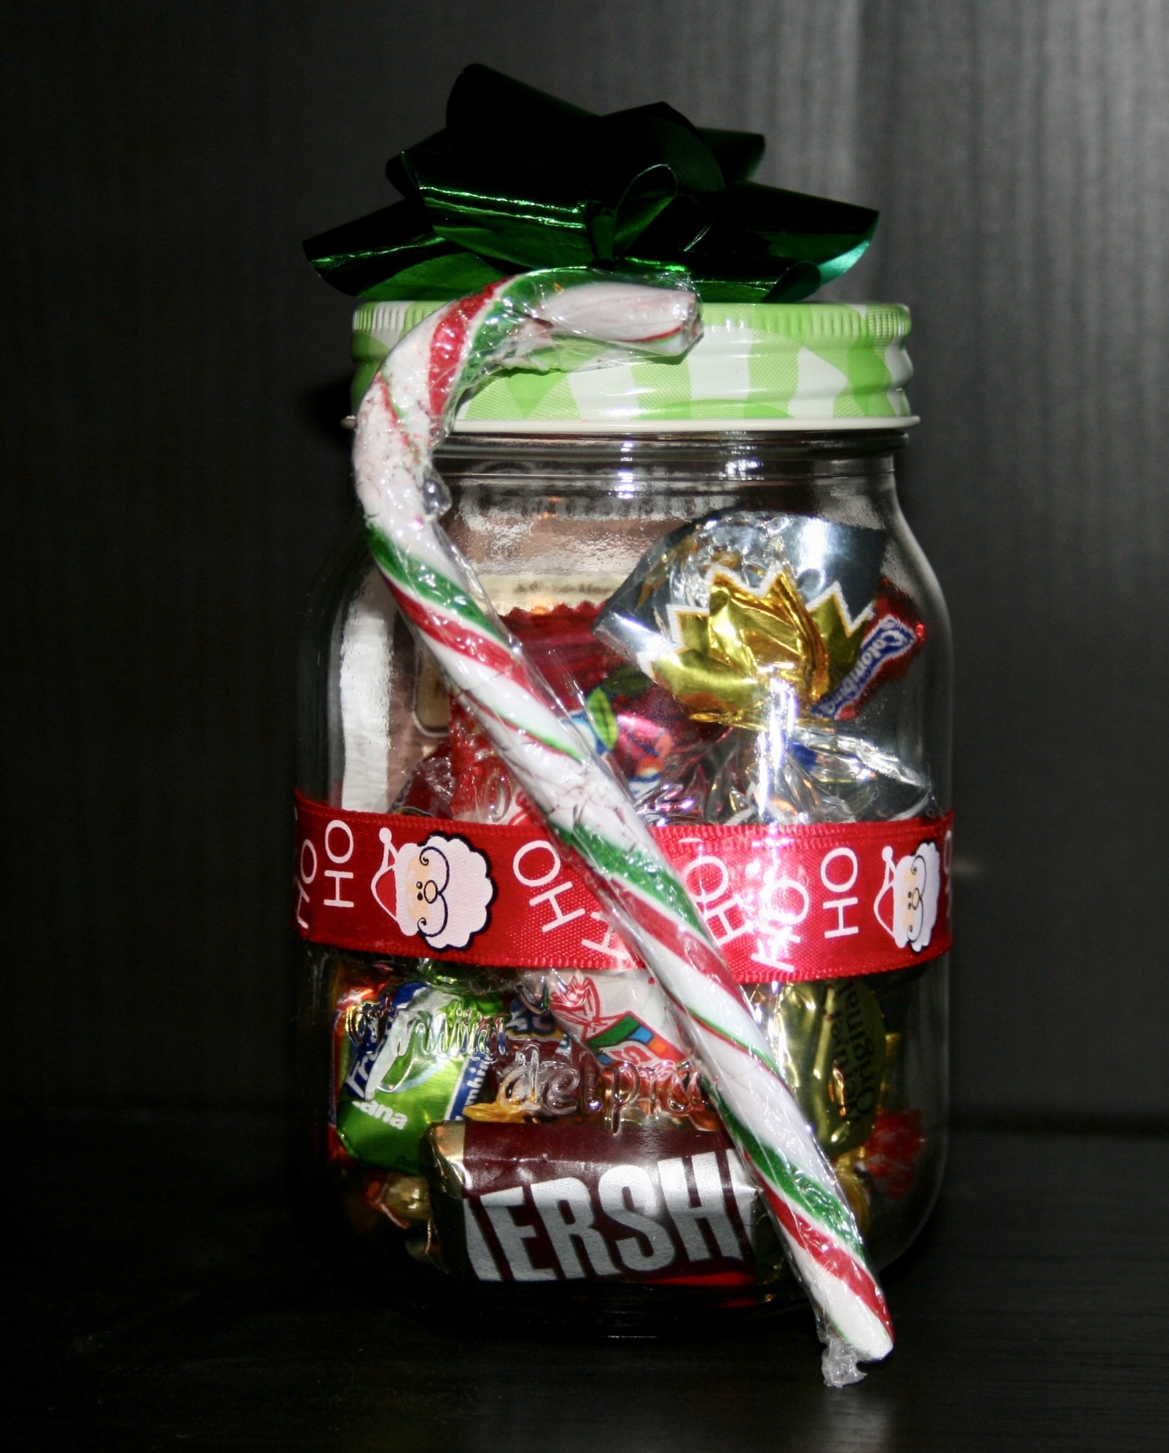

When Rotary facilitated a joint program with London Community Chaplaincy (neighbourhood assistance) and Junior Achievement, a select group of grade 5 and six students were offered the opportunity to join together to form a commercial enterprise and learn the basics of money management and financial literacy.

The test-of-success scoring was hard cash.

A team of Rotarians from the Rotary Club of London-Lambeth re-purposed a Junior Achievement elementary schools program into a neighbourhood after-school group that took the theory of building a business into real life.  Mentored by Rotarians with backgrounds in banking, teaching, entrepreneurship and services, the students were faced with a challenge.

They were offered expert guidance and a short-term loan, which they could leverage into a profitable business - if they successfully adapted the lessons in a series of lectures and demonstrations ranging from business model planning, marketing & promotion, financial record keeping, pricing and teamwork.  Along the way, they also learned about product selection, manufacturing & assembly methods, inventory control, cost controls, sales, interpersonal business relationships and ‘giving back to their community’.

The team of elementary school students chose a product in line with a seasonal theme opportunity (Christmas), they quickly identified their key demographic- parents, grandparents and LCC supporters (mostly local church congregations), choosing sweets & candies that would be attractive to that group.  The students worked out packaging, style & sizing, candies by taste, physical attractiveness, size and pricing, as well as cost and availability.  They learned about production/assembly methods  (elected to use a production-line style of assembly).  They included a quality control person at the end of the line (who had full authority to reject & return for rebuild, unsuitable product).  They learned about unit pricing, product wastage and ’shrinkage’ before and after production and strategic purchasing (buying to ‘catch specials’).  The students designed the product and created sales promotion materials using hard-copy posters, Power-Point displays, Facebook posts and word-of-mouth. The students factored volume discounts on multiple-set purchases into their per-unit pricing model.

They learned about security of product storage (before & after production).  Along with determining all these elements, they calculated marketable selling price, full costing, gross and net profits and shared dividends.  They calculated ‘market saturation’ vs potential demand and market timing - product purchased, stored and assembled but not available for sale within the season would be dead inventory - a cost ‘drag’ to sales volumes.  Finally, they decided upon a percentage of profit to return back to their community through charitable donation, which they recognized would come out of net profits (after repayment of loan) and their individual dividends.

Rotarians guided, advised and mentored; the students made the decisions.  The product pictured is the end-product, designed, priced, promoted, manufactured and sold, to the delight of their target market, on budget and on time.  The project surpassed the budgeted profit and the students learned and worked to make the project a great success.

Rotarians also learned a lot.  Never underestimate the creativity, energy and talent, latent in youth.  Give them the tools, help them and they will succeed.  At the end, celebrate!

Regards,

Geoff Faul

Rotary Club of London-Lambeth