We think of literacy as being able to read and write at a functional level in our society.

But we also now realize the enormously positive impact that music education has on the developing brain.

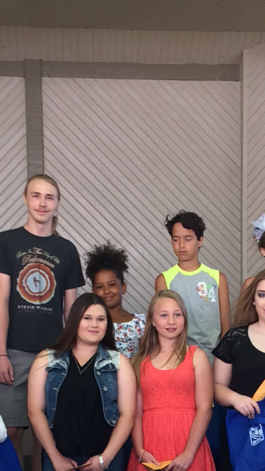

With this in mind, ten years ago the Rotary club of Petrolia began a yearly voice competition for youths ages 5-20. The Rotary Youth Idol Contest is held yearly on the second Saturday in July in Victoria Park in Petrolia during the annual Art in the Park event.

Voice contestants are formally judged by three music education professionals and are given a report with the all important 'next steps'.

Prizes for first, second and third places in all age categories ensure a lively competition! Over the years the contestants return, their voices developing and maturing throughout the year. A corollary benefit of the contest: music teachers in the area note a huge increase in voice lessons!

Participants come from the surrounding local areas but also Detroit, Kitchener and London. Fun is had by all!

Dianne Moore
Literacy chair
Rotary club of Petrolia
