We paired with the Bruce County Public Library, whose head office is in Port Elgin on providing literacy material to infants and their parents. Bruce and Grey Counties have been identified both by the Elementary School system and Children Services as having very poor literacy when entering elementary school.

The project is called "Me, You and a Book Too" and our club provided the funds for approximately 240 bags which will be given to new babies at the Birthing Unit at the South Bruce Grey Health Services. These bags consist of a fine free Library card to the age of 5, an age appropriate board book, posters, talking cards that can be attached to a stroller, growth chart, an instruction book called “Getting Ready to Read”, a coupon to pick up a "Starling" which is a communicator for language and progress is tracked on a computer, and a book bag.

We had a lot of fun at the Walkerton Public Library stuffing bags and visiting the children. Our commitment to the Library is ongoing, they will call on us when more manual labour is required.

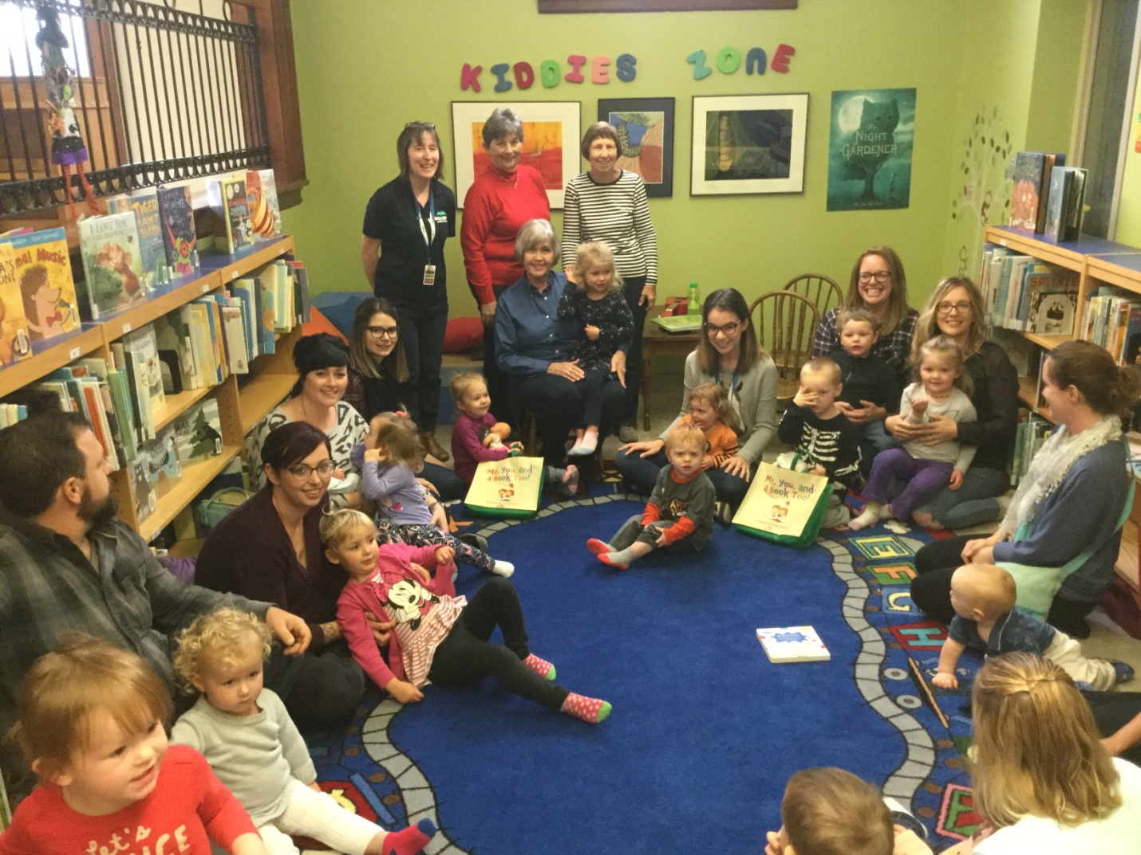

Bev MacDonald, President
The Rotary Club of Walkerton

