District Grants Criteria 2024-25

- Two club members must attend the annual District Grants Seminar.
- President Elects must attend PETS (President Elect Training Seminar) or Alternative.
- Club President and President-Elect must sign Memorandum of Understanding (MOU).
- Written requests for District Grants must be submitted by May 31st, 2024
- The District Grants Committee will review each grant within 30 days the club submission deadline.
- Each approved grant may receive 50% of the grant request, not to exceed $2,500.
  - For example, for $7,500 grant project, if the club commits $5,000., the district grant (district match) may be approved in an amount up to $2,500. (maximum).
- If the total of all approved grants is greater than the available district grant funds, the same percent of the district match may be applied to all approved grant requests or applied as otherwise determined by the District Foundation Committee.
- The project must have some hands-on participation by the club Rotarians who are applying for the grant or Rotarians in another district where the project will be taking place.
- If the project meets basic human needs, the grant can be re-applied. If the project has several phases, each phase is a different project.
- The project must start in the Rotary Year that the grant was applied for. All clubs are encouraged to apply for a District Grant.
- The Club must submit its final report when due (May 15, 2025).
- Describe how the Club will publicize its work on this grant to the community. Please include in final report.

We ask each club to continue to support The Rotary Foundation (TRF). District Grant Funding is determined by the Foundation giving 3 years prior to the current Rotary Year. Charity Navigator has given its highest rating to TRF for the past 13 years.

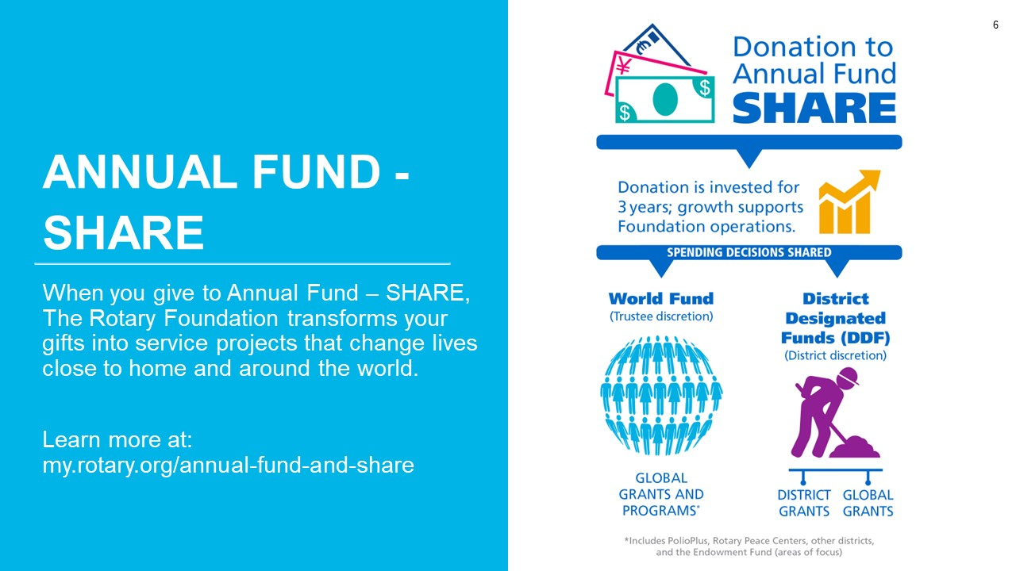

Application Deadline is May 31, 2024
Please direct completed applications to Michael Field
mef41@me.com

Answer fully, by expanding the space between the questions as necessary. No attachments please.

Rotary Club of: _____________________________________

Submitted by: _____________________________________

Email Address: _____________________________________

Phone Number: #1 _____________________________________

Phone Number: #2 _____________________________________
1. Describe your project, its location, objective, and total cost. This is your opportunity to briefly describe the impact of the grant, i.e., why it is needed, what difference it will make, how Rotarians will be involved, or anything else that has your club excited about its merit.

2. Describe how your Club will publicize the grant project.

3. Provide a concise, itemized budget for your project. It is acceptable to categorize your expenses.

4. What is your club’s financial commitment to this project? (Total club contribution)

5. What is the amount of the grant you are requesting? The amount of your awarded grant funds cannot exceed 50% of your Club’s financial commitment to the project, or $2,500.00 – WHICHEVER IS LESS. (Example: If a Club’s financial commitment is $2,000.00 to a project, its awarded grant funds shall not exceed $1,000.00. If a Club’s financial commitment is $5,000.00 to a project, its awarded grant funds shall not exceed $2,500.00. If a Club’s financial commitment is $10,000.00, its awarded grant funds shall not exceed $2,500.00)

6. Identify the cooperating organizations, if any, on your project; which by submitting this application you are endorsing as reputable, responsible, and as acting within the laws of the project country.

7. Provide the names and contact information for the two Rotarians in your Club responsible for sponsoring your project; as well as the names and contact information of two Rotarians implementing this project in the host district, if this is an international project.

Rotarian 1:

Rotarian 2:

8. Provide the names and contact information for the two Rotarians in your Club to whom you have personally given a copy of the Final Report form and who have agreed to be responsible for timely submitting all required project reports.

Rotarian 1:

Rotarian 2:

9. Payment will be sent to your Club for further disbursement to the project. Please
provide the physical mailing address and contact person for your Club.

Mailing Address:

ROTARY FOUNDATION DISTRICT GRANT
2024-25 FINAL REPORT (due May 15, 2025)

D6380 – Rotary Club of ___________________________________

Primary Contact Person ___________________________________

Project Title ___________________________________

Please submit completed final report to District Grants Chair Michael Field at mef41@me.com

Please print or type all information in this report.

- Have there been any changes to your grant since the original application?
  - If NO, go to step 2.
  - IF YES, please explain changes and why.

- How has your club been involved in this project?

- How, if at all, has your Club publicized this grant within the community?

- If your project has partnered with an international club, name that Rotary Club and District. Describe how the international partner was involved.

- Have you partnered with another organization. Describe their involvement.

- Project Start Date: ___________________ Completion Date: _________________

- Please confirm you have kept copies of all documents relating to this project. (Documents must be retained for five years.)

- Please submit the following information with this report:
  - Copy of the Check from D6380 for this project (if your Club had more than one District grant, it may have received one check to cover all grants).
  - Copy of all Checks issues by your club for this project
  - Copy of all invoices for this project
  - Copy of all publicity on this project

All information contained in this report is true and accurate to the best of my knowledge.

Name: ______________________________________

Signature: ______________________________________

Date: ______________________________________

