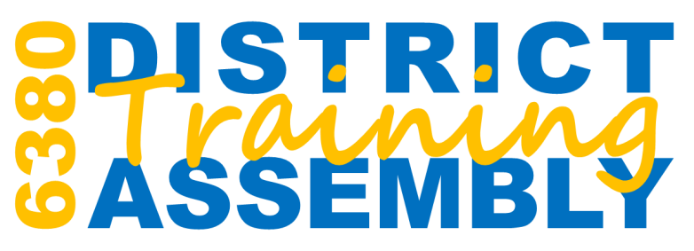

APRIL 14, 2018 | 8:30 AM TO 3:30 PM
Walsh College | Troy, Michigan

The District Training Assembly is a chance for club officers, committee chairs and assistant governors to further develop leadership skills and refine strategies to achieve their goals. All Rotarians who accept key club leadership roles are encouraged to attend the District Training Assembly.

Attending the District Training Assembly is the best way to help your club be even more successful in 2018-19. Attendees will discover tips to take our Clubs and District to the next level.

Breakfast and General Sessions 1

People of Action

A look into Rotary’s newest marketing campaign and find ways you can help launch our new global ad campaign, "People of Action".

Breakout Sessions 1
- Grant Management Seminar Part 1– a must if your club is planning on applying for a grant for 2017-18. Two club officers must attend both Part 1 and 2 to certify before applying for a grant.
- The New Rotary Club Central - Ready to set some goals? We’ll take a deep dive into RCC to help you manage your goals and service activities.
- Visioning – Discover how a club visioning session can give your club a plan for the future that promotes consensus, consistency, and continuity.
- Club Administration – Tips for planning Club meetings, programs, and activities. Explore communication strategies that will keep members engaged.
- Membership – Find out how the changes in membership approved by the COL can help your club recruit new members.

Breakout Session 2
- Grant Management Seminar Part 2
- First Impression – Your Website – Learn how to update your website to create a great first impression – you’ll learn the easy steps to creating a new banner with rotating photos.
- Club Resources – Explore resources available to your club and members on Club Runner, Rotary Club Central, and My Rotary.
- Connecting Community – A look at Rotary Community Corps and Rotary Alumni
- Change Management and Conflict Resolution – Explore strategies to get past the “But that’s not the way WE do things” to help your club make changes, expand membership and enhance your Club’s presence in the community.

Lunch and General Session 2

District Business Meeting

Our official business meeting to discuss and vote on important district matters including the district budget

Polio Update

We’ll look at our progress to date and find way to actively promote polio eradication in our communities.

Breakout Session 3
- Youth Service – Starting and supporting Interact, Rotaract, RYLA programs in your Club
- Club Secretary – Ways to help your Club members get the most our their rotary membership, updating member information, finding resources on My Rotary
- Project Partners – Explore way to connect with other Clubs on a project and explore project resources, including Rotary Showcase and Rotary Ideas
- Classification Study – A classification assessment helps to grow and diversify your club’s membership and make the best use of members’ expertise and skills.
- Connecting Members – Explore ways to connect your members to other Rotarians in your community and across the globe. Discussion will look at Rotary Action Groups, Rotary Friendship Exchange, and Rotary Fellowships.

Breakout Session 4
- Youth Service – Learn tips on recruiting outbound students and the qualification for Inbound Host Families.
- Public Relations – It’s more than Facebook. Discover sound strategies to get the word out about the great things your club is doing.
- Treasurer – Understanding the timeline for dues billing, and review Club financial responsibilities and risk management, review of club budgets and budget tools.
- EREY and Rotary Direct – Develop a case for giving that will increase annual giving to the Rotary Foundation and see how easy it is to create a recurring gift using Rotary Direct.
- Club Membership Plan – How to create a step-by-step plan to strengthen your club and keep it vibrant and relevant to your community.

Register for this important training event today! Registration fee of $20 includes continental breakfast and lunch. Make sure to bring your laptop, ipad, or tablet to this event so you can take notes and participate in the interactive demonstrations.

