Pre-Conference Celebration Event
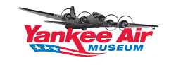
Join the fun at the Yankee Air Museum as we celebrate women in Rotary and Rosie the Riveters.
Come dress in a red and white polka dot bandana!
$50 USD per person
Cash Bar and Heavy Hor D’ovuers

