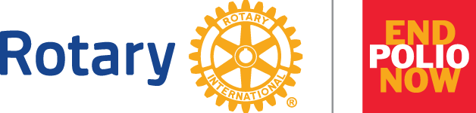

- PolioPlus launched in 1985
- Rotary helped launch the Global Polio Eradication Initiative (GPEI) in 1988 which includes the World Health Organization, CDC, UNICEF, Bill & Melinda Gates Foundation, and GAVI the Vaccine Alliance
- Polio cases have dropped 99.9% since 1988
- Rotary Contributions to date surpass $2.4 billion and countless hours to protect nearly 3 billion children in 122 countries
- Rotary is raising an additional $50 million per year, which will be matched 2 to 1 by the Bill & Melinda Gates Foundation
- Rotary has played a major role in decisions by donor governments to contribute more than $10 billion
- 2023 February 20 2023 update: 28 cases wild poliovirus worldwide, 359 circulating vaccine derived poliovirus
  - Pakistan 20
  - Afghanistan 1
  - Mozambique 7

- A polio-free world is possible, but we can achieve it only by taking action together. Join with @Rotary this #WorldPolioDay to @EndPolioNow: endpol.io/wpd

- How can you triple your impact on #endpolio? Thanks to a 2-to-1 match from the Bill & Melinda Gates Foundation, every donation made to @Rotary to @EndPolioNow will be tripled. Donate today: endpol.io/give

