RYLA IS A THREE-DAY CAMP EXPERIENCE

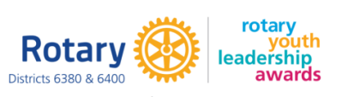

The Rotary Youth Leadership Awards (RYLA) is an intensive training program that brings together our youth, ages 14-18, to further develop character, leadership skills, learn about Rotary and create service projects in our communities centered on the 7 Areas of Focus.

**RYLA will be on May 2-4, 2025** at Camp Copneconic in Fenton, MI. Planning has already started and, our new program is going one of the best that District 6380 & 6400 has ever seen! High school students from your community need to be a part of it! **Registration opens December 2024.**

**OUR RYLA GOALS:** 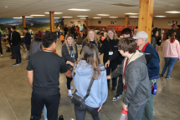

High School Students – Attend as RYLArians to build a

foundation as future leaders, develop tools to find their own

leadership ability, gain confidence to go out and make

positive change. AND come back to their communities to

perform service projects!

College Age Young Adults – Attend as Team Leaders to

provide a safe and inclusive learning environment. Grow as

leaders through guiding high school students in their

leadership development and gain mentorship from our

passionate Rotarian's focusing on the future of Rotary.

Young At Heart Rotarians – Attend as Team Mentors to provide life experience of leadership, personal development, and service to both RYLArians and Team Leaders. Help grow the passion with the next generation to become Rotarians through hands on learning opportunities.

**District 6380 and District 6400 are partnering again!** 

If you, or someone that you know, would be interested in getting more involved in RYLA as a committee member or as a facilitator during the weekend, please let us know. We are always looking for bright faces to improve our team.

For more information, please contact the RYLA Chairs:

**District 6380:**

**Kristina Schofer**

[Ryla6400x6380@gmail.com](mailto:Ryla6400x6380@gmail.com)

(248) 802-8109

**District 6400:**

**Jennifer Ribby**

[Ryla6400x6380@gmail.com](mailto:Ryla6400x6380@gmail.com)

(313) 585- 0117