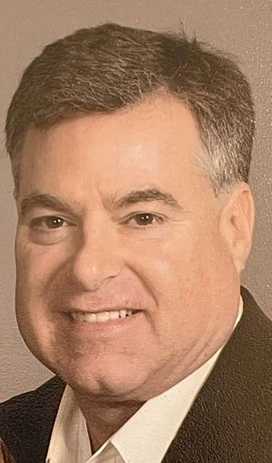
Please welcome Curt Barrett, our new District 6440 Membership Coordinator, to the team. This is a new position for our district with a primary focus on growing membership and helping our clubs attract, engage, and renew their members. Curt will officially begin his new role on June 1st in preparation for the 2026-2027 Rotary year.
Curt is a retired public servant following a 33-year career in city management, working for municipalities including Naperville, Glen Ellyn, and most recently as a credentialed Village Manager in Winfield, which enjoyed historic development during his tenure, reaching both the North Avenue and Roosevelt Road commercial corridors.
Curt was first introduced to Rotary in Glen Ellyn and selected for the 2003 Vocational Group Study Exchange with Finland, where every host owned a sauna. Curt subsequently joined the St. Charles Breakfast Rotary Club in his hometown. There he was able to build a sauna in his basement in time for the Finnish team’s visit, which they heartily enjoyed, and gave him an A- for his American version.
Mr. Barrett has since held several club positions including Club President and served as Assistant Governor 2008-2011. He was also appointed special assistant to the District Governor helping establish the Rotary Club of Carpentersville in 2009. He remains a student of all Rotary has to offer the world.
Curt and his wife Debra share a happy home in downtown St. Charles, with daughter Valerie attending the U of I business school. They are active members of the Baker Memorial United Methodist Church and in his free time Curt enjoys gardening, woodworking, and reading a good book on a sunny day.

