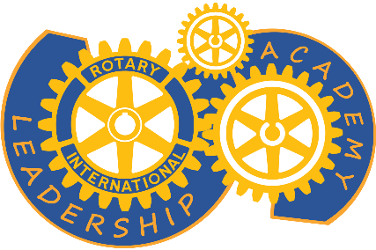
District 6440 Leadership Academy schedule
Rotary Year 2024

October 1 | Registration opens
October 9 and 12 | Introductory / Informational Zoom sessions – program outline, introduction to Canvas, Q&A
October 4 – October 15 | Pre-Course
October 16 – November 15 | Cornerstone Module
November 16 – December 15 | Public Image Module
January 1 – January 31 | Membership Module
February 1 – February 29 | Youth Service Module
March 1 – March 31 | Organization Module
April 1 – April 22 | Foundation Module 1 - The Rotary Foundation: funds, donor recognition, Areas of Focus, Polio Eradication
April 23 – May 15 | Foundation Module 2 – Global and District Grants

Of course, the schedule is subject to change, to reflect changes within Rotary and our District, to accommodate the schedules of our facilitators, and because things happen.

