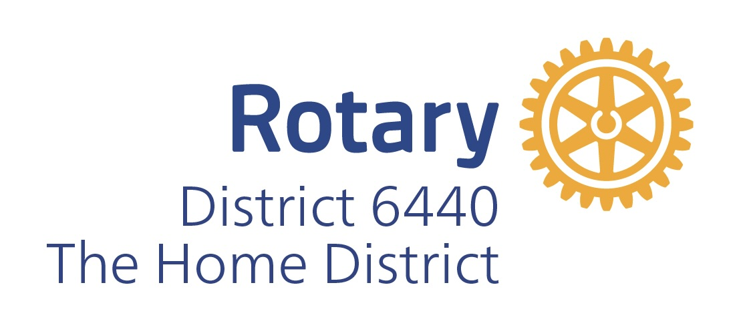

DISTRICT 6440

OFFICIAL PROPOSAL

OF CANDIDATE

FOR THE OFFICE OF

DISTRICT GOVERNOR

Rotary Year 2028-2029

To the District 6440 Nominating Committee:
1. Proposal: We hereby propose and recommend Rotarian ____________________________________ of the Rotary Club of _______________________________________________ as nominee for District Governor of Rotary International District 6440 for the year beginning July 1, 2028, and in support of our recommendation, we present the following information and data regarding their qualifications.
2. Full name:
3. Classification:
4. RI membership ID number:
5. Name of Company or job status:
6. Business Address: __________________________________ Business Phone: ___________________ __________________________________________________________________________________________________________________
7. Home Address: _____________________________________ Home Phone: _______________________ __________________________________________________________________________________________________________________

8. Email: _______________________________________________ Mobile Phone: ______________________ __________________________________________________________________________________________________________________

9. Rotary History:
A. How many years a Rotarian? List all Clubs in which candidate has been a member and dates of membership:
a. ______________________________________________________________________________________________________
b. ______________________________________________________________________________________________________
c. ______________________________________________________________________________________________________
B. Year(s) served as Rotary Club President: _______________
C. Present position in own club: ____________________________________________________________________________ _________________________________________________________________________________________________________________
D. Positions held in Rotary:
Club committees: ___________________________________________________________________________________________
_________________________________________________________________________________________________________________
District/Zone and/or International positions: ___________________________________________________________
_________________________________________________________________________________________________________________
E. Has the candidate attended a District Conference, training, or Rotary International Convention? Please elaborate:

10. Business and Community History:
A. Describe the candidate’s professional background:

B. Leadership positions held in business/professional organizations:
Name of organization | Office | Dates Held | Dates of Membership

C. Provide examples of leadership ability:

11. Social and Civic Organizations:
A. Describe non-Rotary activities (charitable, social, cultural, etc.):

B. Leadership roles in these organizations:
Name of organization | Office | Dates Held | Dates of Membership

12. Personal Information: Educational background or other relevant qualifications:

13. Other special leadership, character, or professional qualifications:

14. Does the candidate have the time, health, and support needed to serve effectively as District Governor? Explain:

15. Experience organizing new Rotary clubs:

16. Additional comments on candidate’s qualifications:

CLUB’S STATEMENT OF CANDIDATE’S QUALIFICATIONS
The candidate is a member in good standing of the Rotary Club of _____________________________.
This proposal was approved by the Club Board on _______________________________________________.
Signature of Club President: _________________________________________________________________________

Signature of Club Secretary: _________________________________________________________________________
CANDIDATE’S STATEMENT
I hereby state that I understand clearly the qualifications, duties, and responsibilities of the office of District Governor as set forth in the Rotary International Bylaws, and that I am fully qualified for said office and willing and able, physically and otherwise, to assume and fulfill the duties and responsibilities of that office and to perform them faithfully. Further, I have read and agree to abide by the District Governor Code of Ethics, as detailed in the Rotary Code of Policies. I agree in advance to accept the decision of the Rotary International Board concerning my election to office without recourse to any non-Rotary agency or other dispute resolution system and further accept that any court costs and attorney’s fees incurred by Rotary International in enforcing this agreement shall be reimbursed by me in their entirety. I understand that if selected, I must attend, for their full duration, the Governors-Elect training seminar in my zone and the International Assembly to be held the Rotary year before taking office. I have read this form in its entirety and certify that all the information provided on this form is true and correct.

Signature of Candidate: __________________________________________________ Date: ____________________

Submit the completed application, resume, cover letter (not to exceed one page stating goals and objectives), and a recent photograph to:
Past District Governor, Thor Davidson
Email: gov.thor@rotary6440.org
Cell: (479) 841-2290
Submission deadline: Friday, August 29, 2025 at 5:00 PM

