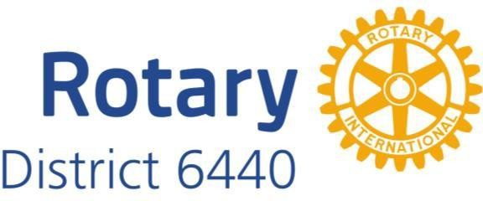

ATTENTION ALL PAST DISTRICT 6440 GOVERNORS

As the Immediate Past District Governor, one of my duties is to chair the District’s Nominating Committee which will meet on Monday, September 12th to choose the District Governor for 2025-2026.

According to our District’s Manual of Procedures, another duty of this committee is to select a Vice-Governor for 202-2024. The Vice-Governor must be willing and able to step in should the District Governor for that year, Mary Bak, be unable to serve, either temporarily or permanently. This position was added in 2013 by Rotary International and must be a Past District Governor.

Each of you has historically given of your time, talent, and treasure to further the cause of Rotary in District 6440 during and beyond your term of office. As Vice-Governor, you would provide that expertise to the District only in an extraordinary circumstance.

Should you wish to put your name in for nomination, please send it to me via email at gov.kevin@rotary6440.org along with any information you feel would be helpful for the selection process.

Interviews will take place for the Governor Nominee on September 12th at the Northbrook Hilton. You do not need to be present on that day, but I will need your letter of interest by September 5th.

Thanks very much for considering this opportunity to continue your service to Rotary in District 6440. Should you have any questions please feel free to contact me.

Yours in Service,

Kevin

Kevin Stevens
262.705.8363
gov.kevin@rotary6440.org
District Governor 2021-2022
Rotary District 6440

