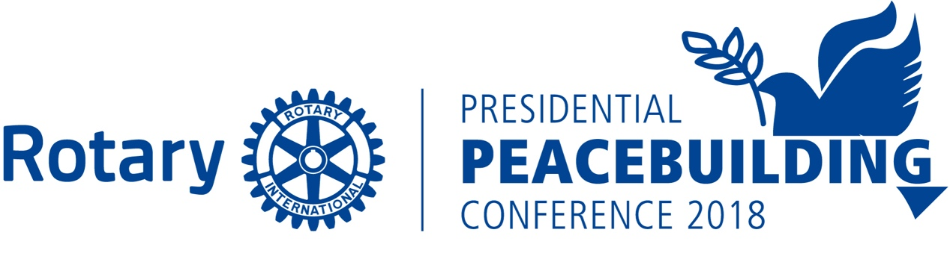

Rotary - United Nations Model Conference
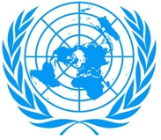
Hearing from the Leaders of Tomorrow – Today

2018 ROTARY PRESIDENTIAL PEACEBUILDING
ROTARY- UNITED NATIONS MODEL CONFERENCE

The Rotary Presidential Peacebuilding Conference focused on Education and Literacy on June 2, 2018 in Chicago will include high school students that will discuss and vote on resolutions related to education and peace. The Rotary-UN Model Conference is being held in conjunction with the Rotary International Peacebuilding Conference which is one of six Peacebuilding Conferences being held world-wide by Rotary International and the only one in the United States.

The high school students will be primarily from low income areas in which students have not been afforded the opportunity to participate in a Model UN Day. The students will include Interact students and non-Interact students. A number of countries that have representation in the UN are each represented by a delegation of three students. These students are selected, sponsored, supported and advised by participating Rotary Clubs in Rotary Zones28-29. The advisor attends the Conference and may be a Rotarian, a teacher or other interested member of the community.

Prior to the Rotary-UN Model Conference, two resolutions are distributed to the participants. The resolutions closely relate to currently pressing international issues and ones that have yet to reach the United Nations. We will debate the provision of Access to School for all students and inclusion of peace classwork during elementary school and courses in peace in high school. Three students will represent a country team and will be located within the same school. Schools will be able to send up to up to 15 students representing 5 countries. 150 students will participate in the Rotary-UN Model Conference.

The students are given training in peaceful conflict resolution, diplomatic negotiating, and analytical thinking and speaking skills. As ambassadors of their particular country, students will research the political, economic, educational, and cultural aspects of their nation in order to develop that country’s position on the resolutions. They will then weave those positions into sponsoring, supporting or opposing speeches directed to the resolutions.

During the one day Conference, the student delegates will break into smaller caucus groups to forge alliances and propose, discuss and draft various amendments to the resolutions that will hopefully satisfy the positions of the various countries. Final votes on resolutions will occur on Saturday afternoon and the unanimity of results will be presented by the student leaders to the Rotary International President Ian Riseley and the Rotarians attending the Rotary Peacebuilding Conference.

The Rotary-UN Model Conference is not a competitive program; there are no winners or losers. We emphasize peaceful consensus building and diplomacy among the activities of all of our high school students. We are excited to have our Rotary Youth Exchange Students joining us representing a diverse group of students from several countries. We focus on inculcating into the students the Rotary spirit of “Service Above Self” and other essential tools to enable them to become effective negotiators, consensus builders and peace makers - skill sets they will use in whatever career they pursue. We hope to inspire the students to become creative problem solvers and perhaps the next community leaders, diplomats or Rotarians of our world.

December 5, 2017

