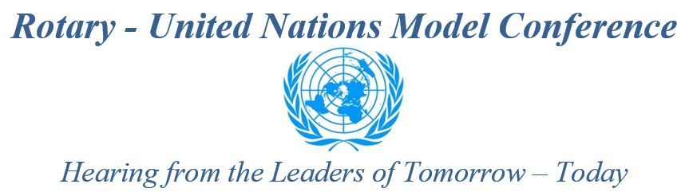

District 6440 Rotary Clubs are asked to help identify high school candidates to participate in a Rotary-UN Model Conference. There is no charge. This will be held in Chicago on Saturday, June 2, 2018, in conjunction with the Rotary International Presidential Peacebuilding Conference focusing on Education and Literacy.

PLEASE HELP US IDENTIFY CANDIDATES FROM DISTRICT 6440! PASS THIS ALONG TO CONTACTS AT YOUR LOCAL HIGH SCHOOLS.

Student teams of three delegates from the same school, supported by an Advisor, will represent a country from the UN's membership. In total, fifty-seven delegations will discuss and vote on resolutions related to education and peace. As ambassadors of a country, students will research the political, economic, educational, and cultural aspects of that nation in order to develop a position on the resolutions, and to sponsor, support, or oppose them. Delegates will be given training in peaceful conflict resolution, diplomatic negotiating, analytical thinking, and speaking skills.

Schools in Rotary Zones 28-29 can propose up to five teams, and while members of Interact Clubs are strongly encouraged to apply, any high school student can be nominated. Preference will be given to students and schools where opportunities to participate in a Model UN Day are limited. Each team must have an Advisor (supporting one or multiple teams), who attends the conference and may be a Rotarian, teacher, or other interested member of the community. There is no charge for participation, and an allowance may be made for transportation.

See the reverse for an explanation of the Rotary-UN Model Conference
THE DEADLINE FOR APPLICATIONS IS THE END OF JANUARY, 2018.

Contact me if you have questions. We're hoping for a good representation from D6440!

Best Regards,

Lyle Staab
Rotary-UN Model Conference Co-Chair
Youth Service Advisor, District 6440 2017-2018
District Governor Nominee Designate
gov.lyle@rotary6440.org
Mobile 845-671-1223

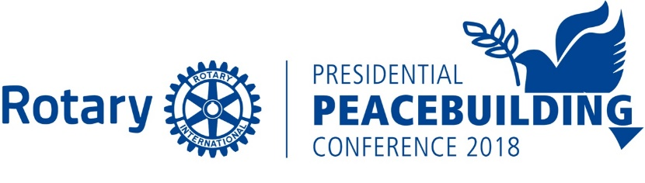

Rotary - United Nations Model Conference
Hearing from the Leaders of Tomorrow – Today

2018 ROTARY PRESIDENTIAL PEACEBUILDING
ROTARY- UNITED NATIONS MODEL CONFERENCE

The Rotary Presidential Peacebuilding Conference focused on Education and Literacy on June 2, 2018 in Chicago will include high school students that will discuss and vote on resolutions related to education and peace. The Rotary-UN Model Conference is being held in conjunction with the Rotary International Peacebuilding Conference which is one of six Peacebuilding Conferences being held world-wide by Rotary International and the only one in the United States.

The high school students will be primarily those that have not been afforded the opportunity to participate in a Model UN Day. The students will include Interact students and non-Interact students. A number of countries that have representation in the UN are each represented by a delegation of three students. These students are selected, sponsored, supported and advised by participating Rotary Clubs in Rotary Zones 28-29. The advisor attends the Conference and may be a Rotarian, a teacher or other interested member of the community.

Prior to the Rotary-UN Model Conference, two resolutions are distributed to the participants. The resolutions closely relate to currently pressing international issues and ones that have yet to reach the United Nations. We will debate the provision of Access to School for all students and inclusion of peace classwork during elementary school and courses in peace in high school. Three students will represent a country team and will be located within the same school. Schools will be able to send up to up to 15 students representing 5 countries. 150 students will participate in the Rotary-UN Model Conference.

The students are given training in peaceful conflict resolution, diplomatic negotiating, and analytical thinking and speaking skills. As ambassadors of their particular country, students will research the political, economic, educational, and cultural aspects of their nation in order to develop that country’s position on the resolutions. They will then weave those positions into sponsoring, supporting or opposing speeches directed to the resolutions.

During the one day Conference, the student delegates will break into smaller caucus groups to forge alliances and propose, discuss and draft various amendments to the resolutions that will hopefully satisfy the positions of the various countries. Final votes on resolutions will occur on Saturday afternoon and the unanimity of results will be presented by the student leaders to the Rotary International President Ian Riseley and the Rotarians attending the Rotary Peacebuilding Conference.

The Rotary-UN Model Conference is not a competitive program; there are no winners or losers. We emphasize peaceful consensus building and diplomacy among the activities of all of our high school students. We are excited to have our Rotary Youth Exchange Students joining us representing a diverse group of students from several countries. We focus on inculcating into the students the Rotary spirit of “Service Above Self” and other essential tools to enable them to become effective negotiators, consensus builders and peace makers - skill sets they will use in whatever career they pursue. We hope to inspire the students to become creative problem solvers and perhaps the next community leaders, diplomats or Rotarians of our world.

December 5, 2017

