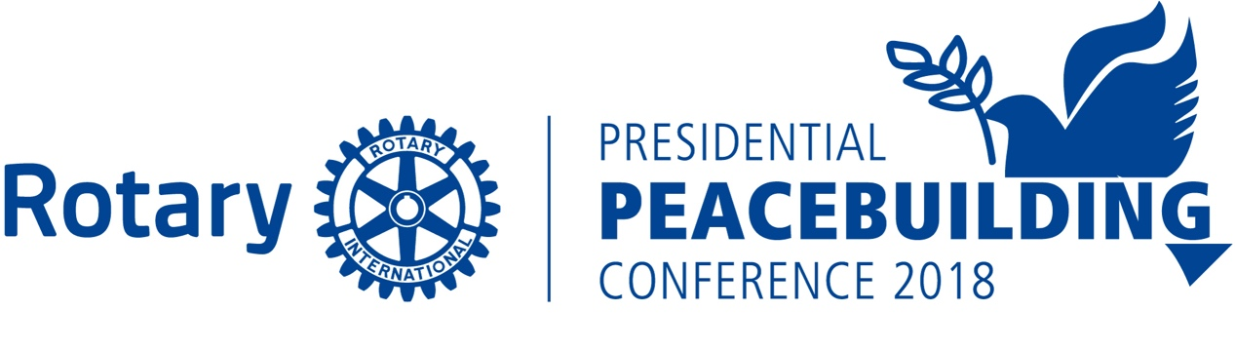

Rotary - United Nations Model Conference
South Shore Cultural Center – Chicago
June 2, 2018
School Registration Form
Student and Advisor June 2, 2018 conference attendance, meals, and if necessary, transportation and Advisor background check are provided by Rotarians – there is no charge for students and Advisors participating in the Rotary-UN Model Conference that is being held at the Chicago South Shore Cultural Center. A Second Faculty or Advisor can be helpful depending on the number of students involved.

School Name:
Location:

Faculty or Advisor Name:
Faculty or Advisor E-Mail Contact:
Faculty or Advisor Phone Number:

Second Faculty or Advisor Name:
Second Faculty or Advisor E-Mail Contact:
Second Faculty or Advisor Phone Number:

Each school can have up to 15 students. Every three students will be assigned to a county and the three students assigned to a country will work as a team.
Team Number | Country | Student Names
Team 1 |  | 1.  2.  3.
Team 2 |  | 1.  2.  3.
Team 3 |  | 1.  2.  3.
Team 4 |  | 1.  2.  3.
Team 5 |  | 1.  2.  3.

Please return this completed form promptly to the Rotary-UN Model Co-Chairs, Nina Menis (nmmenis@gmail.com) or Lyle Staab (gov.lyle@rotary6440.org)

Rotary - United Nations Model Conference – June 2, 2018
Advisor Role to Students
The Advisor to Students for the June 2, 2018 Rotary-United Nations Model Conference is key to the students having a successful learning experience. The Advisor will serve to help direct the students on research and preparation for the Rotary-UN Model Conference.
The Advisor to Students can be a faculty member or a school approved community leader or Rotarian. Since the Advisor will be interacting with students and Rotary has strict child protection policies, we will do a background check on the Advisor if they are not faculty but are approved by the school and are a community leader or Rotarian.
Student and Advisor conference attendance, meals, and if necessary, transportation and Advisor background check are provided by Rotarians – there is no charge for students and Advisors participating in the Rotary-UN Model Conference.
Time Frame | Advisor to Student Timeline
January 2018 | DEADLINE for registration or Advisor and Team. Complete attached form and submit by end of January.  Countries will be assigned by the Rotary-UN Model Committee to Teams as applications are submitted. Advisors will notify teams of their country assignments.  Background checks for Community Leaders and Rotarians serving as Advisors provided through Rotary International
February 2018 | Teams and advisors should establish meeting schedule that works best for them.  Attend live webinar or listen to a recording of Advisor Role and support webinar from the Rotary-UN Model committee.  Meet with students and share how to utilize available resources on their country.
March 2018 | Obtain all Student Permission Slips and Medical Forms and submit to the Rotary-UN Model Contact by March 1.  Initiate discussions with student teams on the two resolutions and how they might be shaping their position on the resolutions based upon their country’s economic, social, educational, governance structure might have on their position.
April 2018 | Students and advisors should select their luncheon meal and submit preferences on forms provided by the Rotary-UN Model Committee.  Students should be working as a team and selecting each team’s spokesperson and preparing their 2-Minute Speech.
May 2018 | Students should be practicing their presentation; understanding their team’s position on the resolutions; prepare notes on possible amendments to the resolutions; and presenting at a local Rotary Club if applicable.
June 2, 2018 | Attend the Rotary-UN Model Day and celebrate your students’ achievements in taking on a diplomatic leadership role today and for the future.

Rotary - United Nations Model Conference

Student Preparation for Rotary-UN Model Day

Time Frame | Research
February 2018 | See Background Country Research Outline – Understand your country’s political organization, economics, crime, and education
March 2018 | Discuss Your Country’s Position on Two Resolutions with your country team. Share among your team amendments to the resolutions that you might want to introduce to make the Resolution more acceptable to your country.  Turn in all parental/guardian permission and medical forms to your Advisor.
May 2018 | With your country team, for the person the team selects to give the speech, practice speech presentation.  Speeches should be timed to two minutes and as a team presented to their Interact Club or School international program, and local Rotary Club, if applicable.
June 2, 2018 | Engage in lively discussions on resolutions; listen to each country’s position; debate and form amendments and positions within your caucus; sharpen your diplomatic skills; and be positioned to take leadership roles in your school and community.

