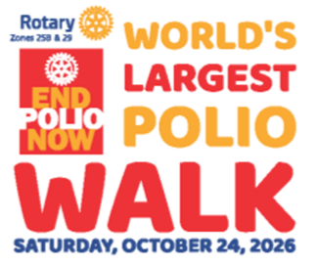
“Top 10” Polio Facts
- More than 20 million people are walking or alive today because of the polio eradication efforts of Rotary and our partners.

- Since 1988, when the Global Polio Eradication Initiative was launched, more than three billion children have been immunized against polio.

- Since 1988 only two countries, Afghanistan and Pakistan, have never stopped the transmission of the wild poliovirus, down from 125.

- Up to 370 million children are vaccinated each year in polio-affected and high-risk countries to sustain high population immunity because as long as the poliovirus circulates anywhere in the world it is a threat everywhere.

- During four-day polio immunization campaigns, over 45 million children under the age of five are immunized in Pakistan and over 11 million in Afghanistan.

- There are 146 specialized polio laboratories around the world. Collectively they test over 200,000 stool samples every year.

- It costs on average US$0.73 to immunize a child against polio in Afghanistan and US$0.52 in Pakistan, including the cost of the vaccine and activities required to deliver the vaccine to children. A child must receive multiple doses of polio vaccine to be fully protected and therefore must be reached multiple times.

- In Pakistan, there are over 300,000 frontline health workers, mostly women, who provide vaccinations to children during immunization campaigns.

- Through the PolioPlus program, Rotary provides US$150 million/year for the polio eradication efforts carried out by WHO and UNICEF.

- If polio is not fully eradicated, we could see a global resurgence of the disease with as many as 200,000 new cases each year within the next 10 years.

