
Saturday October 24th 10am Largest Polio Walk:
- Objectives:
  - Goal is to count people who are walking to make the largest walk!
    - Educational
    - Engage community and families.
    - Make it easy for someone to come out and join
    - Low cost to families
    - Fun.
    - Plenty of photo opportunities
    - Rotary publicity
    - Fundraising options
    - Low cost to Rotary
  - Not required:
    - Need not be long walk.
    - Need not be walking for money.
    - Do not need to get sponsors for you to walk.
    - Not just Rotarians
    - Not a full day
    - Need not be BIG (ok to do just local with our club for Antioch/ LV/Lindenhurst)
- Space needed for:
  - parking
    - might need traffic control
  - Gathering
    - Electricity?
    - Bathroom access
  - Walk
    - Big enough for the masses
    - Need not be a long “walk”
  - Location ideas:
    - Osmond Park (no rain option),
    - ACHS (unable to easily get to the track but good inside rain option with hallways and gym),
    - AUGS (good for inside and out – what does gym look like too?)
    - Williams Park to new park (no rain option),
    - LCHS (good for both inside and out, but not ANTIOCH)

- Speakers
  - Raised stage – Welcome, Polio info, other
  - Possible videos (not so easy to see if sunny and outside)
- Booths
  - Purple pinkee – Interact club?
  - Face painting – (try to get donated!)
  - Autographs from someone famous (who???)
  - Donation station
    - cash, checks, square, venmo/zelle
    - 50/50?
  - Education –
    - A walk in the past with some history info
    - Try walking in the metal braces
  - Walk registration: need to count number in each party
    - Inexpensive laynards with numbered printed badge
  - Tshirts
    - Get vendors to donate and be on back of shirt?
    - One per registered party of 4 or more
  - Sign station (poster boar on sticks)
    - Rotary is 99.99% there
    - Only __ cases in the last year*
    - Irradicate Polio forever
    - Polio killed ___ people in ____
    - Remove the fear – be polio free
    - Rotary’s network administered Covid-19 vaccinations
    - Only $___ to vaccinate a child
    - Donate now
    - Help End Polio Now
  - Concessions – (get donated?)
    - Coffee, hot chocolate, water & donuts / fruit
    - Napkins
    - Water jugs and cups
    - Garbage and recycling bins and bags
- Walk
  - Clearly marked start (balloons / signs)
  - Maybe milestone signs along the way (timeline for Polio history)
  - Clearly marked end (balloons / signs)
  - Walkers to receive something (what? See if can get it donated)
- Time:
  - Event 9:00-11:00am
  - Setup start 7:00am
  - Cleanup done by 1:00pm
- Need people!
  - Setup
  - Speakers – keep it short!
  - Local representatives: Mayors, congressmen
  - Famous people – get commitment as The Draw?
  - Past polio or polio knowledgeable
  - Doctors / Nurses with Polio knowledge
  - Volunteers to manage food and garbage
  - Photographers

- Other
  - Place to store everything in preparation
  - Move items to venue
  - Trash collection

- Budget:
  - Expenses:
    - Venue
    - Event signage – entry, stations, walk start and finish, walk milestones,
    - Festive – balloons, station table covers
    - Carry posters
    - History station
    - food and drink
    - T-shirts
    - laynards for walk participant count
    - Giveway at end of walk
  - Revenue:
    - Cost to register party of 4
    - 50/50
    - Donations
    - Vendor donations on tshirts
    - Vendor donations on event sign

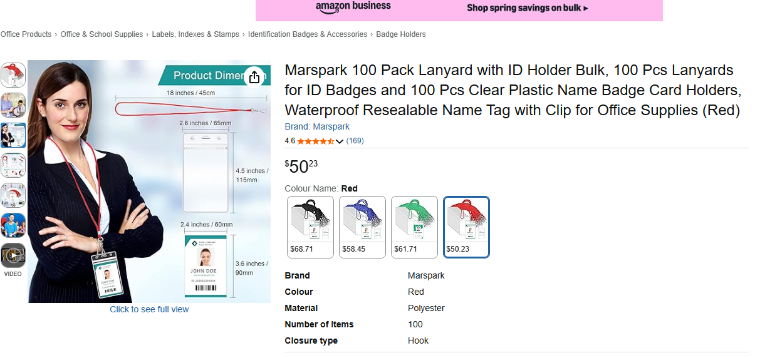

Cost about $1 per person for lanyard and a “badge” to be printed and inserted

END POLIO NOW
Oct 24, 2026
Walker
2

END POLIO NOW
Oct 24, 2026
Walker
1



