Get your club involved, tell your story, and help us celebrate World Polio Day!



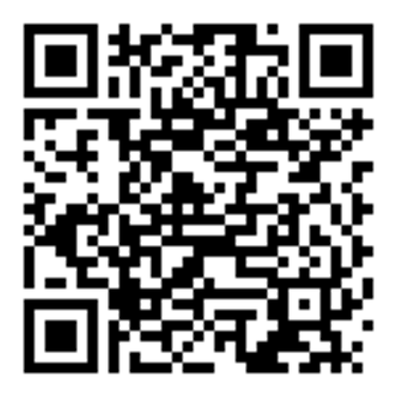

Be part of our zone-wide event by joining 22 other districts across 13 states and two countries to raise awareness about Polio

Scan the QR code above or go to
https://www.rotary6440.org

For more information contact:
gov.rickrg@gmail.com

