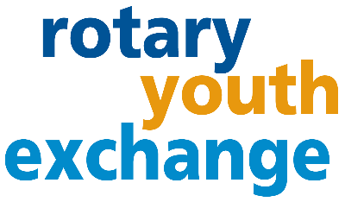 **District 6440**

**2023-24 Long-Term Youth Exchange:**

**Frequently Asked Questions**

**WHAT IS ROTARY LONG-TERM EXCHANGE?**

A unique opportunity for students to experience another culture while attending high school. Live in another country for 10-11 months, learn a new language, and build life-long friendships. Students are typically hosted by 2-3 families.

**WHAT APPLICATION REQUIREMENTS ARE THERE?**

Age 15 ½ - 18 ½ at time of exchange and have good grades (upper 50% of their class and/or 2.75 GPA.) and open to differences in the world.

**HOW MUCH DOES THE PROGRAM COST?**

The program average overall family cost is $7300. The cost can be higher based on country selection and related fully refundable airline ticket, insurance(s), and participation in any option year-end tours. The estimate includes gifts for host parents and children, language camps, luggage, a $850 non-refundable application fee, and $2200 fees paid in the Spring. Host families are responsible for lodging and family meals. Host clubs provide at least a $75 monthly allowance.

**WHAT COUNTRIES CAN I GO TO?**

Because District 6440 is part of Central States Rotary Youth Exchange (CSRYE) with 19 other districts, the countries selection is optimized offering about 40 destinations. Most countries participate in Rotary Youth Exchange with the US. Exceptions are Australia, Canada, China, UK, and any countries deemed unsafe at this time. If you are learning a language already, we encourage you to consider utilizing this opportunity to practice your speaking skills, but don’t limit yourself – go ahead learn something brand new.

**ARE THERE ANY MANDATORY MEETINGS?**

There are several mandatory training in the Spring and a July three day conference in Grand Rapids Michigan both before and after the exchange. The student is expected to attend the sponsoring local Rotary Club before and after their exchange. Additional Rotary events will occur during the year such as: District Conference; District parties; Rotary Youth Leadership Award weekend experience; service projects; and fun outings. These events will be communicated as optional or highly suggested.

**WHAT IS ROTARY?**

Rotary is a non-profit service organization made up of over 1.4 million volunteers globally. In 1905, Paul Harris started Rotary in Chicago and rotated locations – which was the inspiration for the Rotary wheel symbol. Today Rotary International headquarters is in Evanston. Rotarians have a passion for “Service Above Self” and promoting peace around the world through friendship and understanding. Rotary Clubs can sponsors Interact clubs in High Schools.

**WHAT ARE MY RESPONSIBILITES IF I AM CHOSEN?**

Students act as ambassador and represent your country, state, city and Rotary. Be pleasant, embrace new experiences, people, and cultural differences with an open mind. Abide by all Rotary program rules (no drinking, no driving, no drugs and no dating). Attend and do your best in school. Ask for help when needed. Go prepared by participating in training, learning basic language skills, and planning on time for your experience. Be prepared to share your experiences with potential exchange students. Students that have a mix of curiosity and respect do well in this program.

**WHAT ARE MY PARENTS RESPONSIBILITIES IF I AM CHOSEN?**

Parents must agree to support both the student and the Rotary program by attending required meetings, assist in the application process, and aid in other preparations for the exchange. Parents are requested to also share their experience in the recruitment process.

**WILL MY EXCHANGE YEAR APPLY TO HIGH SCHOOL GRADUATION?**

That depends on the school. Talk to your counselor regarding options to stay on track for graduation (summer school, online courses, heavier load) and what, if any, overseas classes will count as credit.

**INTERESTED? APPLY!**

Complete a preliminary application at no cost. Turn it into your local Rotary Club Youth Exchange Officer (YEO) based on their deadline (usually early/mid-September). The Club representatives will interview you and your parents to provide the next steps of the application process.

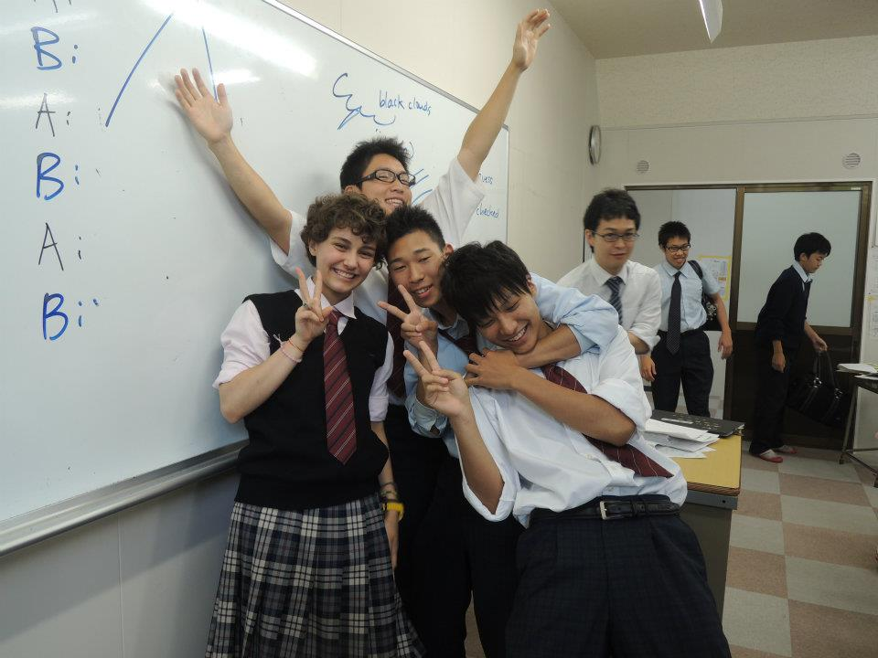  
**CLUB CONTACTS:**

**DISTRICT 6440 CONTACTS: (email)** [**RYE.chair@rotary6440.org**](mailto:RYE.chair@rotary6440.org) **or**

Long-term-Outbound Coordinator: John Kent (phone) 773-259-0838

Youth Exchange Chair: Rebecca Dunleavy (phone) 847-997-3603

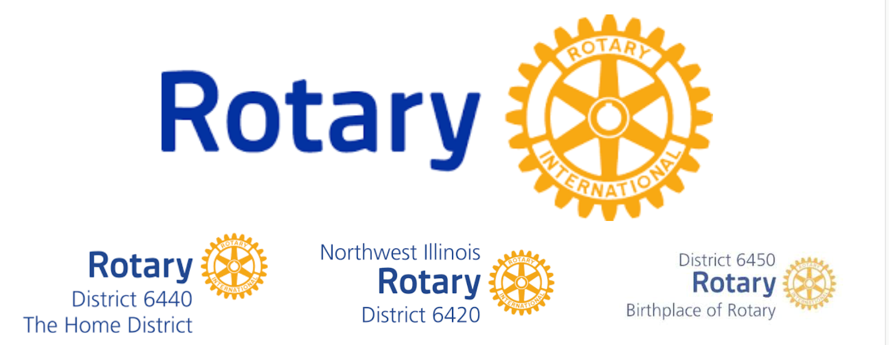

***COVID-19 IMPACT: The health and safety of everyone involved in the Rotary Youth Exchange program is important to us.*** *Rotary is monitoring the Covid-19 situation globally. The exchange program timing and options might be adjusted or be canceled if we do not feel confident or comfortable with the situation.*