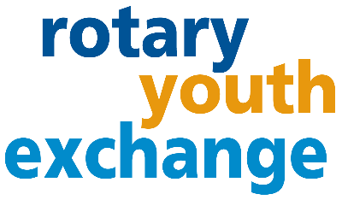
District 6440
Hosting an Exchange Student:
Frequently Asked Questions
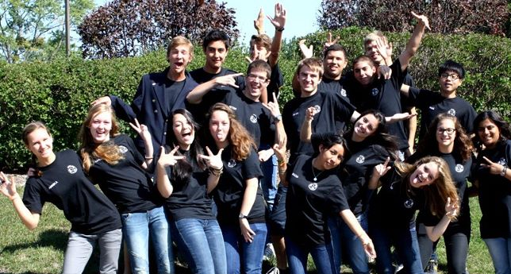
HAVE AN EXCHANGE WITHOUT LEAVING HOME.

WHAT IS ROTARY LONG-TERM EXCHANGE?
A unique opportunity for students age 15 ½ - 18 ½ to experience another culture while attending high school. They live in another country for 10-11 months, learn a new language, and build life-long friendships. Students are typically hosted by 2-3 families. That can be you!
WILL THE STUDENT SPEAK ENGLISH?
Because District 6440 is part of Central States Rotary Youth Exchange (CSRYE) with 19 other districts, the countries selection is optimized offering about 40 destinations. Not all student that come to the United States fluent in English. They are encouraged to start learning the language as soon as they know that United States is their destination. Online modules are made available to the students to help. Students immersed in a new language usually can hold conversations within several months.

WHAT ARE OUR RESPONSIBILITES IF WE ARE CHOSEN?
Host families are responsible for lodging and family meals. The student must have a bed of their own (sharing a bedroom with same gender child is ok), and a place to study.

Rotary asks that Host Families treat the students as part of their own family. They are to live by your family rules. Rotary has a 1st night questionnaire to help discuss those expectations with the student. In addition, the student is expected to attend school, do their best in their classes, and abide by all State and Federal laws and follow Rotary program rules (no drinking, no driving, no drugs and no dating).

Host parents are requested to help the students become familiar with the local area and activities but are not expected to be a tour guide or be running a hotel or limo service. Determining transportation to events is a joint discussion.

WE DO NOT HAVE ANY CHILDREN LIVING AT HOME ANYMORE, CAN I STILL HOST?
Yes! Hosting an exchange student does not require there to be other children living in the home.

I’M A SINGLE PARENT, CAN I STILL HOST?
Yes! Single parents can host a student of the same gender. Additional screening is done, and the student family must agree to this situation.
WHO IS PAYING FOR THE PROGRAM?
The program cost is mostly covered by the student families and Rotary. The Hosting Rotary club provides the student with a minimum $75 monthly allowance. Rotary might also decide to pay for school lunches, provide a phone or phone line, and support some student events. The Host Families are requested to treat the student like their own children during family outings.

ARE THERE ANY MANDATORY MEETINGS?
In addition, the family must complete a Rotary Youth Exchange Host Family training which normally takes a few hours and online Youth Protection training.
WHAT IS ROTARY?
Rotary is a non-profit service organization made up of over 1.4 million volunteers globally. In 1905, Paul Harris started Rotary in Chicago and rotated locations – which was the inspiration for the Rotary wheel symbol. Today Rotary International headquarters is in Evanston. Rotarians have a passion for “Service Above Self” and promoting peace around the world through friendship and understanding. Rotary Clubs can sponsors Interact clubs in High Schools.
HOW DO I BECOME A ROTARY EXCHANGE STUDENT HOST PARENT?
The Club representatives will interview you and provide the next steps of the application process which includes a home visit to confirm the setup is appropriate for the Youth Exchange program, that all adults in the family undergo a Criminal Background Check, and reference checks.

INTERESTED? APPLY!
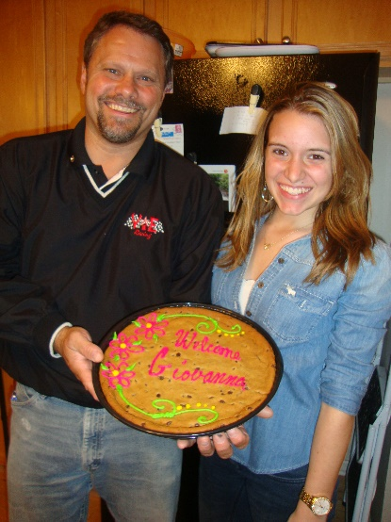
Contact your local Rotary Club for an application. Or contact District representatives for more information if you do not know who your local contacts are.
CLUB CONTACTS:

DISTRICT 6440 CONTACTS: (email) RYE.chair@rotary6440.org
Long-term Inbound Coordinator:
Youth Exchange Chair: Rebecca Dunleavy (phone) 847-997-3603

COVID-19 IMPACT: The health and safety of everyone involved in the Rotary Youth Exchange program is important to us. Students must meet the US and local school vaccination requirements. Host families are encouraged to be fully vaccinated too. Rotary is monitoring the Covid-19 situation globally. The exchange program timing and options might be adjusted or be canceled if we do not feel confident or comfortable with the situation.

