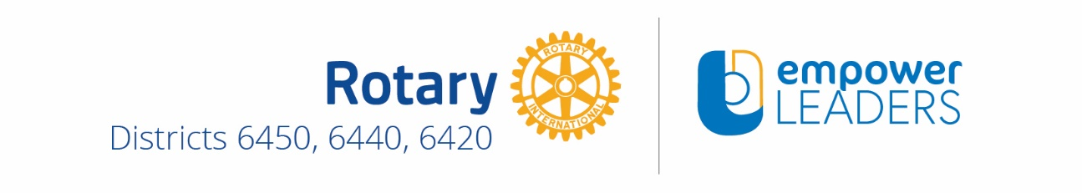
Leadership Award Winner Selection Criteria, Instructions, Terms & Conditions
- The Protégé must demonstrate the potential to excel as a leader, to make a difference in society and meet the following criteria -
  - A high school senior or college/community college student accepted for enrollment at an accredited institution and participating in a program that culminates in either a 2 or 4-year or graduate degree or vocational/technical certificate
  - Young adult professional
  - A United States citizen
  - Reside within any of the northern Illinois counties covered by Rotary Districts 6420, 6440 and 6450 as outlined below

Boone | DuPage | Kankakee | Marshall | Rock Island | Winnebago
Bureau | Grundy | Kendall | McHenry | Stark
Carroll | Henry | Lake | Mercer | Stephenson
Cook | Jo Daviess | LaSalle | Ogle | Whiteside
DeKalb | Kane | Lee | Putnam | Will

- The empowerLEADERS Leadership Award is a one-time only award per winner to be used for education related expenses including but not limited to tuition and enrollment fees, books, supplies and/or professional leadership training and development seminars and materials.

- Winner(s) is/are required to provide a short follow-up essay documenting how and where they utilized the funds to further their education and advance their leadership skills no later than October 14, 2018 that should be e-mailed to scholarshipchair @empowerLEADERSbyNorthernILRotary.com.

- The empowerLEADERS Leadership Award Application is a MS Word document containing fillable fields and is available for download at our website – www.empowerLEADERSbyNorthernILRotary.com. To simplify application review by the award selection committee please type your answers in the designated fields.

- Completed application - consisting of all three pages of this document - should be e-mailed as a PDF attachment to scholarshipchair@empowerLEADERSbyNorthernILRotary.com no later than 12:00 am midnight, Sunday, April 1, 2018.

- For the Protégé’s application to be considered both the Mentor and Protégé must be registered to attend the empowerLEADERS – a morning of leadership, mentorship and scholarship event scheduled for Saturday, April 14, 2018 at Oakton Community College in Des Plaines no later than April 1, 2018. Tickets may be purchased at our website www.empowerLEADERSbyNorthernILRotary.com.

- Failure of both the Mentor and Protégé to register for the event by the above-mentioned date will disqualify the Protégé’s application.

- Children of Rotarians are eligible to apply for this award.

- Winner(s) will be announced at the April 14, 2018 event and must be present to receive their award. This award may be a taxable event for the individual. All federal, state, and local taxes on the award are the winner's responsibility. Tax forms will be provided when the award is presented. We recommend that you consult with your tax advisor or accountant regarding this matter.

- Winner(s) agrees to provide an appropriate photo in addition to being photographed and videotaped at the event. Your image will be featured in the empowerLEADERS program press releases, on our website and social media sites, and in future event marketing and program support materials (print, digital and audio/visual).

- Our steering committee encourages award winners to attend future empowerLEADERS program events to join with their fellow alumni in sharing personal achievements and growth experiences and by being an inspiration to future leaders!
Today’s Date: Click or tap to enter a date.
Protégé Signature By signing this page Protégé indicates that they have carefully reviewed the instructions and information provided and agree to abide by the terms and conditions as stated above.
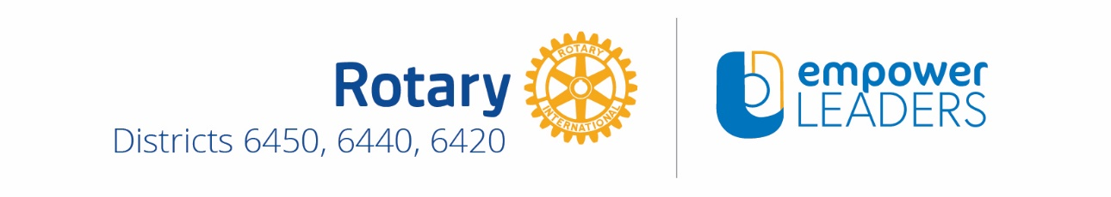
Application must first be initiated by the Mentor.
Completed applications should be a joint effort between the Mentor and their Protégé.
Today’s Date: Click or tap to enter a date.
Mentor Contact Information
- Name: Click or tap here to enter text.
- Phone: Click or tap here to enter text.
- E-Mail: Click or tap here to enter text.
- Employer Name & Address: Click or tap here to enter text.
Mentor Signature

By signing this application Mentor certifies that the information provided herein is accurate regarding their Protégé.
Protégé Contact Information
- Name: Click or tap here to enter text.
- Address: Click or tap here to enter text.
- Phone: Click or tap here to enter text.
- E-Mail: Click or tap here to enter text.

- If you are a high school senior or college/community college student –
- What school, college or university will you / are you attending and where is it located?
Click or tap here to enter text.
- Have you been accepted for enrollment at this school? Yes ☐ No ☐
- What is your intended course of study? Click or tap here to enter text.

- If you are a young adult professional –
  - Employer Name & Address: Click or tap here to enter text.
  - What is your current position? Click or tap here to enter text.
Protégé Signature

By signing this application Protege certifies that the information provided herein is accurate.

Short Essay Questions – Limit your response to each question to no more than 150 words
- All questions must be answered to qualify for this award
- Questions 1 – 4 are to be completed by the Protégé
- Question 5 is to be completed by the Mentor

- Rotary’s Motto is “Service Above Self”. Describe your passion for service and how that contributes to effective leadership.
Click or tap here to enter text.

- If you could change one thing in the world what would that be and why?
Click or tap here to enter text.

- Who is/has been your role model and why?
Click or tap here to enter text.

- How will you use this award to further develop your leadership skills and advance your opportunities for service?
Click or tap here to enter text.

- Protégé Recommendation Statement – to be completed by your Mentor
Click or tap here to enter text.

