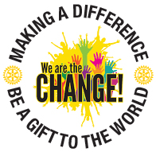

The Rotary Interact Little Library Service Project

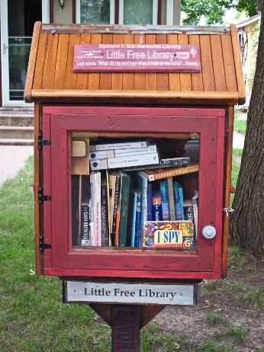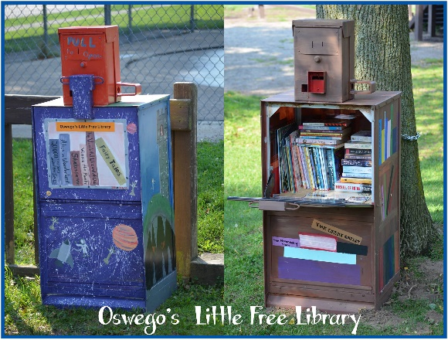

The goal of the Interact Little Library Project is to support the Rotary literacy initiative and increase the visibility of Rotary and Interact in our communities. Over the next three years we want to have one or more little libraries in each of our Rotary Club communities. Chicago had the cows, Rotary District 6440 will have the little libraries with books to share!
We encourage each of our Interact Clubs to either build, repurpose an item or create the plans for a little library to be built later. All will be on display at the District Conference. Be creative, imaginative and innovative!
More information on the Little Library movement can be found at the following links
https://www.rotary.org/myrotary/en/do-it-yourself-libraries
http://littlefreelibrary.org/history/
Any Interact Club built library or plans, displayed on a poster board, need to be delivered to the District Conference on Thursday, April 28th between 3PM and 6PM or on Friday, April 29th by 9:30AM.
Please contact Vera Mayer with questions, v_ mayer@msn.com , and 708-508-6388

