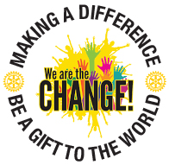

Attention Rotary District 6440 Interact Students
Do you sing?
Do you have a unique talent that you would like to share?
Then we want you!!!
If selected you could be a participant in the
Youth Service Talent Show
at the Rotary District 6440 District Conference on
Saturday evening, April 30th

District 6440 Interact Choir
Be a charter member of the District Interact Choir.
Rehearsals: Sunday, April10th and 24th, 2:30-4:30PM, location in Prospect Heights. Pre-selection music will be provided to the participants.
Interested in joining us email Charlotte Ogorek by April 5th charlotte.orgorek@sbcglobal.net with student’s contact information: name, e-mail, phone number, parent’s e-mail and phone number
Talent Show
We need a description of the performance , can be individual or group, any equipment needs, length of performance.
Send an e-mail to Vera Mayer v_ mayer@msn.com by April 5th
with student’s contact information: name, e-mail, phone number, parent’s e-mail and phone number

