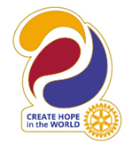
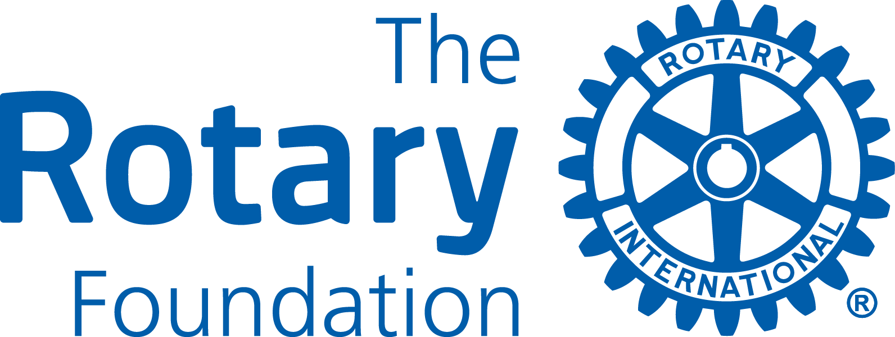 district grant application
d7000
2023-2024

application form
Please type all information required. Instructions can be found at the end of this document.

GENERAL INFORMATION

Rotary Club
Project Title
Area of Focus
Short Project Synopsis

If your Club has previous District Grants, have the final reports been submitted and accepted? | _______ Yes  _______ No

2. project descrition
Overview/Goal
Location
Partners (if any)
Project start/finish
Other information

3. How will this project benefit the community?
Please describe the benefits for the local and/or international community from this project.

4. Rotarian/rotaractor participation
Please describe any non-financial participation by Rotarians/Rotaractors in the project, including an estimate of volunteer hours. This might include needs assessment and partnership development, hands-on participation, and communication strategies to enhance the profile of Rotary and The Rotary Foundation.

Estimated hours in the project by Rotarians/Rotaractors

5. Project Contacts
The Primary (applying) Club must appoint a committee of at least three Rotarians from the Club to oversee the project. The committee members must be committed for the duration of the grant process. Please provide the mailing and email address for all committee members. The primary contact will receive all official communication from District 7000 and should be prepared to disseminate this information to the other committee members.

Contacts
- Name
- Address
- Phone/email
- Name
- Address
- Phone/email
- Name
- Address
- Phone/email

6. Project budget
 | Item/Supplier | Amount (CAD)
Total
Any unused District Grant (DDF) funds must be returned to the District.

7. sources of funds
Total Project Budget
Project Financing  - Primary Club Cash  - Other D7070 Clubs (please list clubs & cash contributions)  - Other, please specify  - District Grant request | Club and other supporting organizations Amount CAD  District Grant Request  Total Budget

8. ownership of equipment, materials oR SUPPLIES
a. Who will own equipment, materials, or supplies? (Materials and supplies may not be owned by a Rotary club)

b. Who will be responsible for maintenance, operating, and/or cost of the equipment/supplies?

9. rotary BRANDING & Public image
How will the general public know this is a Rotary and/or Rotary Foundation sponsored project? Please provide details about outreach to media outlets (television, print & online), social media promotions, and how the Rotary Masterbrand Signature and the Rotary Foundation logo will be used on project materials and communications.

10. co-operating organizations
If the project involves a co-operating organization, please provide the name of each organization below and attach a letter of participation from the organization that specifically states its responsibilities and how Rotarians will interact with each organization in the project. By signing this application, the Rotarian sponsor endorses the organization as reputable, responsible, and acting within the law.
Name(s) of Co-operating Organization(s):

11. authorization
11a. Progress and Final Reporting Requirements
The Primary Club is required to complete and submit progress and final reports to the District Grant Sub-Committee. Please indicate below the individual who will take primary responsibility for submitting these reports.

11b. Club President’s Authorization
As President of the Rotary Club of
I hereby affirm that the club has voted to undertake this project as an activity of the club.
 | 11a. Primary Rotary Club Contact | 11b. Primary Rotary Club President
Name
Signature
Date
Phone
Email

Please save the completed form and submit your application by e-mail to:

Georgie Hildebrand D-7000 District Grant Sub-Committee Chair

georganna57@gmail.com
Proposals received by April 30, 2023 will be considered for the initial 2023-24 Spending Plan.

Instructions

District Grants are used to support short-term projects of individual Rotary clubs in District 7000. Clubs apply to the District 7000 Grant Sub-Committee which decides the merit of each application and the degree to which they will be funded. An application is not a guarantee for a grant!

The Rotary Foundation Terms & Conditions for District Grants
District Grants must comply with the Terms and Conditions of The Rotary Foundation, including the relating to the mission of the Rotary Foundation (see below). These terms and conditions are available on the District Grants page of the district’s website at www.rotary7000.org and at www.rotary.org.

The mission of The Rotary Foundation of Rotary International is to enable Rotarians to advance
world understanding, goodwill, and peace through the improvement of health,
the support of education, and the alleviation of poverty.

District 7000 Grant Guidelines
- Projects must fall within one of the following seven areas of focus:
  - Peace and conflict prevention/resolution
  - Disease prevention and treatment
  - Water and sanitation
  - Maternal and child health
  - Basic education and literacy
  - Economic and community development
  - Environment and Sustainability
- The deadline for District grant applications is November 1, 2023 to be considered for approval by the Rotary Foundation and included in the District’s annual Spending Plan for District Designated Funds (DDF).
- The Primary (applying) Rotary Club in a project must be qualified according to The Rotary Foundation rules..
- Applications must be for an original effort; recurring projects will not be funded.
- The budget for a project must be minimum $1,000.
- No single club may receive more than $5,000 in District Grant funds for projects during the Rotary year.
- Any unused District Grant funds allocated to a specific project must be returned to the District. This may occur for any number of reasons (e.g. the project does not happen, the project expenses are less than budgeted, fewer clubs participate etc.).
- An application is not a guarantee for receiving a District Grant.

District 7000 Evaluation Criteria
Proposals will be evaluated taking the following criteria into consideration.
- Members’ hands-on involvement, where the degree of direct involvement by Rotarians is considered. .
- Impact of the project in the community, where among other things the demographic of the individuals being served is considered.
- Ability of a project to enhance the understanding and profile of Rotary and The Rotary Foundation in the community being served.

Timelines for Applications, Project Execution & Reporting
- Submission Deadline - Applications for the 2023-24 Rotary year received by August 1 will be considered for the District’s application to The Rotary Foundation for a District Block Grant (Spending Plan) for the 2023-24 Rotary year.
- Review All applications received before the dead-line will be reviewed by the District Grants Sub-Committee in November 2023.
- Notification – The Committee aims to notify clubs of award decisions at the end of November 2023.
- Funds will be presented to successful clubs as soon as they are received from The Rotary Foundation.
- Project Execution - Clubs should strive to have projects completed by April 30, 2024.
- Reporting - A final report is due no later than two months upon completion of a project but no later than April 30, 2024 . A District Grant report form is available at www.distritorotario7000.org.
- Documentation – Club reports and supporting documentation for all expenditures must be maintained by the club for at least 5 years following closure of the grant.
- Promotion. Clubs are encouraged to present completed projects on websites, in social media, Rotary Showcase and other vehicles they may find useful.

