Activity type | Activity description | Location | Amount (CAD$)
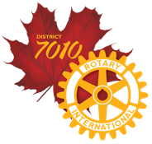
District 7010 Disaster Response Grant Application Form

Our District is in the process of applying for a District Response Grant of US$25,000 to be distributed to Clubs with approved COVID-19 projects only. This is completely separate from the District Grant application process, but will follow the same allocation process and the same Eligibility Requirements, with the exception of the submission deadline of May 31, 2020.

Please submit your completed form to: Kim Giffen, District Foundation Committee by May 31, 2020.

Club:
Contact:
Email:

May 2020

