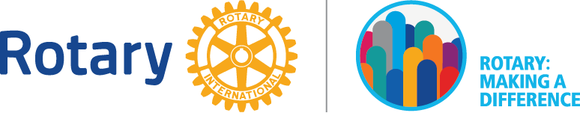
Application – Public Image Grant 2017-18
Due before March 1, 2018

Each Rotary club in District 7170 may apply for up to $250 to enhance Rotary’s Public Image within their community. Grant funds may be used to buy (or help buy) signs, local advertisements, boost social media posts and anything else the club determines will get the word out, locally, about Rotary.

Applications will be evaluated as they are received and they will be judged according to the following criteria:
- The application is complete
- Club has named a public image chair, who is responsible for completing the grant project
- Budget for the project is established and an invoice submitted
- Number of local residents the project is estimated to reach
- How the project will be evaluated for effectiveness
- Whether the club will submit photos or final report to District PR committee

Date Applied: _______________________________________________________________

Name of Club: ______________________________________________________________

Club President: (print name)______________________ (sign)_____________________________

Club Public Image Chair: (print name)_______________________(sign)_____________________

Project Contact: (name)__________________________________________________________

(address)______________________________________________________________________

(email)________________________________________________________________________

Brief Project Description: ____________________________________________________________________________________________________________________________________________________________________________________________________________________________________________________________________________________________________________________________________________________________________________________________________________________________________________________________________________________________________________________________________________________

Budget: _____________________________________________________________________

Will the Club Or Other Community Organization also contribute to the project? Yes ___ No___

Will this project make use of the People Of Action campaign material available on rotary.org Brand Center? Yes ___ No___

Expected Project Reach: ________________ local residents

Anticipated Start Date: _________________ Anticipated Completion Date: ________________

How will the project be evaluated?_________________________________________________
________________________________________________________________________________________________________________________________________________________
Please return this to Jackie Sands, Rotary District 7170 Public Image Chair 2017-18 at jackiecsands@gmail.com

Completed applications will be reviewed as they are received, but must be received before March 1, 2018.

